
Governor
Date of EOP

Copy #1

Fayette County Emergency Operations Plan

December 1, 2014

Volume I: Basic Plan

Copy Number _________

Table of contents
RELATED SUPPORTING PLANS 6
FOREWORD 7
EXECUTIVE SUMMARY 8
CERTIFICATION OF BIENNIAL REVIEW 10
PROMULGATION 11
I. PURPOSE AND SCOPE 15
A. Purpose 15
B. Scope 15
II. SITUATION AND ASSUMPTIONS 16
A. Situation 16
B. Assumptions 17
III. CONCEPT OF OPERATIONS 18
A. General 18
B. Intergovernmental Assistance 18
C. Direction, Control, Coordination and Support 19
D. Continuity of Operations Planning (COOP) 24
E. Political Subdivisions Adopting the County Plan as Their Own 24
IV. RESPONSIBILITIES 26
A. ESF Responsibilities 26
B. Command Staff 26
C. Operations Section 30
D. Planning Section 35
E. Logistics Section 36
F. Finance and Administration Section 40
V. EOC ADMINISTRATION AND LOGISTICS 43
A. Administration 43
B. Logistics 43
VI. TRAINING AND EXERCISES 44
A. Policy 44
B. Exercise Requirements 44
C. Training Requirements 44
D. After Action Reports 45
VII. PLAN DEVELOPMENT, MAINTENANCE AND DISTRIBUTION 46
A. Development and Maintenance Responsibilities 46
B. Distribution 46
APPENDICES 48
APPENDIX 1 - AUTHORITIES AND REFERENCES 48
APPENDIX 2 - TERMS AND DEFINITIONS 50
APPENDIX 3 - PLAN DISTRIBUTION 60
APPENDIX 4 - MAP OF THE COUNTY 65
APPENDIX 5 - POLITICAL SUBDIVISIONS THAT HAVE ADOPTED THIS PLAN AS THEIR OWN 67
FUNCTIONAL CHECKLISTS AND BLANK FORMS 70
ELECTED OFFICIALS 73
ATTACHMENT 1 - TO ELECTED OFFICIALS CHECKLIST 74
EOC MANAGER AND EMERGENCY MANAGEMENT COORDINATOR (EMC) 75
PUBLIC INFORMATION OFFICER (PIO) - (External Affairs - ESF 15) 82
ATTACHMENT 2 - TO PIO CHECKLIST 85
LIAISON OFFICER CHECKLIST 86
DAMAGE ASSESSMENT PROCESS 87
BLANK FORMS 93
EOC INCIDENT MESSAGE FORM 95
MESSAGE LOG 99
INCIDENT CHECK-IN LIST - ICS form 211 100
ICS 214 104
PEMA RESOURCE REQUEST FORM 107
RESOURCE REQUEST STATUS LOG (name of municipality) 110
INITIAL DAMAGE REPORT WORKSHEET 112
INDIVIDUAL ASSISTANCE FORM 2 116
DISASTER DAMAGE ASSESSMENT - PUBLIC PROPERTY 119
MUNICIPALITY - COUNTY INITIAL DAMAGE REPORT (IDR) WORKSHEET 121
DAP 19 - LOCAL DAMAGE ASSESSMENT FORMS 123
INDIVIDUAL ASSISTANCE DAMAGE DEFINITIONS 126
SBA CONSOLIDATED FORMS 129
PDL Survey 129
PDL Sample Survey 131
PDL Consolidation 134
PDL Sample Consolidation 138
New EIDL Survey 142
Sample EIDL Survey 144
EIDL Questionnaire 146
EIDL Sample Questionnaire 147
EIDL Survey 149
EIDL Sample Survey 151
Implementation Procedures 153

Table of figures
Figure 1 64
Figure 2 108
Figure 3 119
Figure 4 122
Figure 5 123
Figure 6 124
Figure 7 125
Figure 8 126
Figure 9 129
Figure 10 131
Figure 11 134
Figure 12 135
Figure 13 136
Figure 14 138
Figure 15 139
Figure 16 140
Figure 17 142
Figure 18 144
Figure 19 146
Figure 20 147
Figure 21 149
Figure 22 151

RELATED SUPPORTING PLANS

1. Nuclear/Radiological Emergency Response Plans
2. Hazardous Materials – SARA Plans
3. Emergency Action Plans for Hazard Potential Category 1 and 2 Dams
4. Continuity of Government Plan/Continuity of Operations Plan
5. Hazard Mitigation Plan
6. Special Events Plans
7. Prison Plans
8. School Plans
9. Strategic National Stockpile Plan
10. Pandemic Influenza Plan
11. Regional Task Force Plan
12. Debris Management Plan
13. Volunteer Management Plan
14. Donations Management Plan
15. Animal Care and Control
16. Mass Casualty/Mass Fatality Plan

FOREWORD

The County Emergency Operations Plan (EOP) outlines how the County Government complies with and implements the requirement of the Pennsylvania Emergency Management Services Code to protect the lives and property of the citizens of the county. The county EOP serves as a bridge between the Local Municipal Emergency Operations Plan and the Pennsylvania State Emergency Operations Plan (SEOP).

EXECUTIVE SUMMARY

General: This plan prescribes emergency response procedures for Fayette County, while it reflects the structure of emergency management throughout the Commonwealth of Pennsylvania and the nation. This plan serves as an emergency management link between local municipalities and state government while incorporating the federal organizational concepts of the National Response Framework (NRF.)

All emergency response activities within the county will utilize the National Incident Management System (NIMS). This includes prescribed incident command structures that will be used by local emergency responders at the scene of emergencies, and at the county Emergency Operations Center (EOC).

This plan employs a functional, all-hazards approach that manages the assistance that the county is likely to need or provide by defining fifteen (15) Emergency Support Functions (ESFs). These functions are basically the same as those at the state and federal levels.

Organization: The plan is divided into four sections, all published separately. This allows users to separate those portions that may contain personal information (the items in Sections III and IV) or information that may need to be kept confidential.

Section I contains:

- The Basic Plan which describes procedures and principles for organizing emergency response throughout the county. It contains overarching structures and assigns responsibilities to various organizations in the county.
- A listing of Related Supporting Plans that;
  - depend on this plan for assignment of responsibilities and operational principles and may supplement this plan during specific emergencies,
  - because of regulatory requirements or the specific nature of the hazards they address, should stand alone,
  - are published separately, and incorporated into this plan by reference,
  - In some cases contain personal or sensitive information and are exempted from the provision of the Right-to-Know Law, and from release to the general public.
- Appendices that provide additional information (definitions, explanation of terms, maps, etc.) that will be helpful during emergency response.

Section II contains: ESF Annexes that describe the fifteen emergency support functions and how they will be accomplished.

Section III contains:

- Functional Checklists that provide suggested tasks for each of the principal positions in the county EOC.

- Blank Forms that will be needed for the operation of the County EOC, and for reporting damages and other operational data to state government.

Section IV contains: Notification and Resource Manual (NARM) that contains a listing of those resources, facilities, personnel, equipment and supplies that are available to the county, along with contact information that will be needed to procure that resource for use during an emergency. It also contains the names of persons and facilities that require special notifications.

CERTIFICATION OF BIENNIAL REVIEW

CERTIFICATION OF BIENNIAL REVIEW

This Emergency Operations Plan has been reviewed by the Fayette County Emergency Management Agency.

Date | Signature

PROMULGATION

THIS PLAN IS PROMULGATED AS THE FAYETTE COUNTY EMERGENCY OPERATIONS PLAN. THIS PLAN IS DESIGNED TO COMPLY WITH ALL APPLICABLE STATE AND COUNTY LAWS AND REGULATIONS AND PROVIDES THE POLICIES AND PROCEDURES TO BE FOLLOWED IN DEALING WITH NATURAL OR HUMAN CAUSED EVENTS OR DISASTERS.

THIS PLAN SUPERSEDES ALL PREVIOUS PLANS.

PROMULGATED THIS _______________ DAY OF ______________, 2014.

_________________________________________________
COMMISSIONER CHAIRPERSON

_________________________________________________
COMMISSIONER VICE CHAIRPERSON

_________________________________________________
SECRETARY COMMISSIONER

_________________________________________________
CHIEF CLERK/ADMINISTRATOR

(OFFICIAL SEAL OF THE COUNTY)

_________________________________________________
EMERGENCY MANAGEMENT COORDINATOR

THIS PAGE IS INTENTIONALLY LEFT BLANK

I. PURPOSE AND SCOPE

A. Purpose

- This plan is to prescribe those activities to be taken by County government and officials to coordinate emergency response activities, provide support to their citizens, and interface with the private sector, political subdivisions and the Commonwealth government for the purpose of protecting lives and property in the event of a natural or human-caused event or disaster.
- This plan serves to satisfy the requirements of the Pennsylvania Emergency Management Services Code.
- This plan is designed as an “All-Hazards” plan. Its organization into Emergency Support Functions allows it to be used for disasters and emergencies of all types.

B. Scope

- The plan will apply to all emergencies that require county-level response and occur within the geographic boundaries of the County, and to the use of county emergency response assets for response to emergencies in other counties and jurisdictions.
- The plan is applicable to all assets of county government and supporting emergency response organizations within the county and volunteer organizations or individuals who will support county response to disasters or emergencies.

II. SITUATION AND ASSUMPTIONS

A. Situation

- County Location and Description:

Fayette County is located in the Southwest portion of Pennsylvania and encompasses a land area of 794 square miles. According to the 2010 Census of the United States, the population of the county is 148,644. Uniontown City, the county seat, is located in the South Central portion of the county. Approximately 52% percent of the county is forest, 68.9% percent is agriculture, 33% percent is considered rural and 33% percent is considered urban. There are 763 miles of state and federal highways and 1437 miles of secondary and municipal roads in the county. The County is comprised of 42 local municipalities and has 7 School District(s).

- County Capabilities and Resources:

  - The Jurisdiction 9-1-1 Center serves as an emergency communications hub for the entire jurisdiction.
  - The 9-1-1 Center operates 24/7.
  - Mutual Aid and Support: The County is a member of the Southwest PA Emergency Response Group (Region 13) Regional Task Force. The county also has numerous mutual aid agreements with surrounding counties.

- County Hazard Vulnerability: The County is subject to a variety of hazards. According to the county Hazard Vulnerability Analysis (HVA) contained in the County Hazard Mitigation Plan, the most likely and damaging of these are:

  - Flash Flood
  - Flood
  - Tornado & Wind Storm
  - Winter Storm

B. Assumptions

- A major disaster, emergency or terrorism event may cause numerous fatalities and injuries, property loss, and disruption of normal life-support systems, and will have an impact on the regional economic, physical, and social infrastructures.
- The extent of casualties and damage will depend on factors such as the time of occurrence, severity of impact, weather conditions, population density, building construction, and the possibility of cascading events such as fires, explosions, structural collapse, contamination issues, loss of critical infrastructure and floods.
- A major disaster or emergency will overwhelm the capabilities of the local municipal governments along with their emergency response agencies.
- The county will coordinate and support the activities of multiple political subdivisions in accordance with the provisions of the Pennsylvania Emergency Management Services Code. The County Emergency Management Agency may need to respond on short notice to provide timely and effective assistance.
- Using the tiered response system, resources and capabilities of the regional task force may be requested by the county to provide additional coordination and support, in accordance with The Counterterrorism Planning, Preparedness and Response Act of 2002.
- Upon a determination that resource requests exceed or may exceed locally available resources, the county will request assistance from the regional task force or the Pennsylvania Emergency Management Agency (PEMA).
- The occurrence of a major disaster or emergency may result in the declaration of a disaster emergency by the Governor. Depending upon the severity of the event, the Governor may request a Declaration of Emergency or Major Disaster from the President, or a declaration of Economic Emergency from the administrator of the Small Business Administration.
- The Pennsylvania Intrastate Mutual Aid System (PIMAS) will make aid available to the county and all of its political subdivisions that have not opted out of the system.
- PIMAS will be utilized in response to emergencies and disasters that require actions beyond the capacity of the local municipality or the county in which the incident occurs.

III. CONCEPT OF OPERATIONS

A. General

- NIMS: All emergency response within the county will follow the National Incident Management System (NIMS) that has been specified by the U.S. Department of Homeland Security. This includes:
  - The designation of an Incident Commander, and, if necessary, an Incident Management structure;
  - The use of resource definitions specified by NIMS; and
  - Communication and planning protocols used in NIMS.
- Phasing: All disasters start at the local level. Response will start there as well, and will escalate with the scope of the incident.
  - Initial response to disasters, emergencies and terrorism related incidents is normally handled by local responders, dispatched by county 9-1-1.
  - If it appears that the incident will grow beyond the capabilities of the locality, or if more than one local municipality will be involved in response, the county EMA will assist with coordination of the efforts.
  - If local resources become overwhelmed, the county will provide supplemental assistance.
  - If county resources are not adequate, the county EMA will turn to other counties, the Regional Task Force and/or the state for assistance.

B. Intergovernmental Assistance

- The County EMC and elected officials will develop agreements with nearby counties as well as incorporating support from state government. Non-routine requests for out-of-county support will be processed through the County EOC or EMA office.
  - The county is a participant in the Pennsylvania Intrastate Mutual Assistance System (PIMAS) and utilizes the Mutual Aids Instructions document (The PIMAS process can be found at http://www.pema.state.pa.us/portal/server.pt/community/programs_and_services/4547/intrastate_mutual_aid/685158)
  - The regional task force will provide materials and equipment as well as assistance in the form of specialized incident support teams (ISTs/IMTs) as available.
  - Adjacent Counties and other governments will render assistance in accordance with the provisions of PIMAS and other mutual aid or intergovernmental support agreements in place at the time of the emergency.
  - The provisions of Regional Task Force Plans, the County 9-1-1 plan and the associated mutual aid agreements will also apply.
  - The county EMA and other agencies will establish regular communication with state agency offices supporting the county (Pennsylvania Departments of Agriculture and Transportation, State Police, etc.)
  - Requests for unmet needs will be forwarded to the state EOC through the PEMA Western Area Office (ph: 800-972-7362)

C. Direction, Control, Coordination and Support

- County Elected Officials are responsible for the protection of the lives and property of the citizens and they exercise ultimate control of emergency activities within the county.
- The Emergency Operations Center (EOC) will be used for decision-makers to exercise direction and control of county operations, to gather information and to coordinate activities of the responders during emergency situations.
  - The EOC is not normally activated, but will be activated as needed.
  - The location of the EOC is listed in the Notification and Resource Manual (Section IV of this plan).
- The Emergency Management Coordinator (EMC) may act on behalf of the County Elected Officials. The County EOC may be activated by the EMC or the elected officials during an emergency.
- The County EOC will use an operational structure that is based on the Incident Command System defined in the National Incident Management System. This mirrors the structure used at the state and outlined in the National Response Framework (NRF).
EOC MANAGER
OPERATIONS
PLANNING
LOGISTICS

PIO
SAFETY OFFICER
LIAISON OFFICER
FINANCE

Figure 1 – EOC Incident Management Structure

- The initial Incident Command/Unified Command (IC/UC) at an incident site will be from the service having primary jurisdiction (fire, police, emergency medical services, etc). As an incident progresses, the primary jurisdiction may change. If the line of jurisdiction becomes unclear, a unified command should be formed.
  - The on-site IC will coordinate with the respective municipal emergency management coordinator as much as possible.
  - If the county EOC is operational, it will coordinate with the scene through the local EMC (if available). If the local EMC is unavailable, the IC/UC at the incident site will coordinate directly with the county EOC.
  - The EOC Manager in the EOC will NOT assume command of those resources on-scene. The EOC will support the efforts of the on-site IC/UC.
- Emergency Response will be managed through the fifteen Emergency Support Functions outlined in Table 1. The actual functions of the ESFs are detailed in Sections II and III of this plan.

- ESF | FUNCTION | PRINCIPAL DUTY
1 | Transportation | Provide/control transportation resources and infrastructure.
2 | Communications | Provide/maintain telecommunications and Information Technology (IT) resources.
3 | Public Works & Engineering | Provide engineering and heavy equipment support.
4 | Firefighting | Suppress fires and assist local firefighting efforts.
5 | Emergency Management | Coordinate countywide emergency response functions; collect/share/analyze/disseminate information; track resources; arrange for the reception and distribution of goods; coordinate debris management.
6 | Mass Care, Shelter, & Human Services | Coordinate shelter and feeding operations.
7 | Logistics Management and Resource Support | Provide equipment and supplies.
8 | Public Health & Medical Services | Coordinate medical care, public and crisis counseling and mortuary services.
9 | Search & Rescue | Coordinate search and rescue missions including: urban, wilderness and underground.
10 | Oil & Hazardous Materials Response | Respond/assist in incidents involving release of petroleum or other hazardous materials that may harm humans or the environment.
11 | Agriculture & Natural Resources | Provide bulk food supplies; monitor animal feed and food production facilities and the health of livestock and food crops; coordinate animal safety/sheltering, protect natural, cultural and historic resources.
12 | Energy | Maintain and restore the supply of energy.
13 | Public Safety & Security | Provide physical security for citizens and their property: suppress criminal activity.
14 | Long Term Community Recovery and Mitigation | Protect and restore human services, infrastructure and business environment in the disaster areas.
15 | External Affairs | Provide information to the public through direct means and through the public media. Manage Public Inquiry and community outreach.
Table 1: Emergency Support Functions

- Within the EOC, the ESFs have been assigned to the general staff sections of the incident command structure (Figure 2). This provides for better coordination and control. As situations require, direct collaboration between ESFs will be conducted.

EMS/Medical
Branch Director (ESF # 8)

Law Enforcement
Branch Director (ESF # 13)
EOC Manager
PIO
External Affairs
ESF # 15
Liaison Officer
Operations
Section Chief
Logistics
Section Chief
Planning
Section Chief
Finance & Admin.
Section Chief
Fire/Rescue
Branch Director ESF # 4, 9 & 10

ESF # 2
Support
Branch Director ESF # 3, 7, & 11)

Situation
(ESF # 5)
Comms.
Unit Leader
(ESF # 2)
Service
Branch Director (ESF # 1, 6, & 12)
Cost
Unit leader
Safety Officer
Agency Representatives
Figure 2 – County EOC Organization
- In those cases where an ESF is not staffed, ICS doctrine dictates that responsibilities and activities of that ESF revert to the section chief. If the section chief position is not filled, the responsibilities revert to the EOC Manager.
- The County EMC will monitor local events through media outlets, internet sites, the county 9-1-1 center, reports from PEMA or the National Weather Service or other sources. Based on impending events, the EOC manager will consider a partial or full activation of the EOC.

- Other Emergency Plans may be applicable and provide detail to supplement this plan:
  - An incident involving hazardous substances, weapons of mass destruction or a nuclear power plant incident may involve response prescribed by other (incident specific) plans (Regional Task Force Response Plan, SARA Plan, Nuclear/Radiological Emergency Response Plan, High Hazard Dam Plan, etc.). These plans provide additional information or details, but do not supersede or replace this County EOP.
  - If the incident involves implementation of response plans at various levels, the county and state Emergency Management Agencies shall serve to coordinate to the maximum extent practical to ensure effective actions.
- Integration of Response, Recovery and Mitigation Actions:
  - Following a disaster, immediate response operations to save lives, protect property, and meet basic human needs have precedence over recovery and mitigation. Recovery actions will be coordinated and based upon availability of resources.
  - Mitigation opportunities will be considered throughout disaster operations.
- Activation of the County Emergency Operations Center (EOC):
  - The EOC Manager will determine which ESFs are needed in the EOC. The EOC Manager will contact the required ESFs.
  - Activation of the EOC will be phased in four levels (See Table 2), with Level IV being normal operations, and Level I involving a maximum effort on the part of County EMA and both paid and volunteer staff.

PHASE | EVENT | SCOPE | EXAMPLES
LEVEL IV | Normal Operations, routine, localized events with relatively minor damages | 9-1-1 center monitoring the situation, EMA on call
LEVEL III | Threats that require situational awareness, planning or possible county-level response | County EMA staff reports to the EOC or incident site to monitor needs for county or out-of county resources
LEVEL II | Threats that require increased situational awareness, coordination or damage assessment | Partial mobilization of EOC Staff, & ESFs as required.
LEVEL I | Catastrophic damage involving the entire county or neighboring counties | Full mobilization of EOC Staff with all available ESFs.
Table 2 – Levels of EOC Activation

D. Continuity of Operations Planning (COOP)

The County Continuity of Operations Plan (published as a separate, related plan) contains procedures to ensure that county government continues to provide services to the citizens.
- Lines of succession specify replacements for principal elected officials should the incumbents be unable to perform the responsibilities of their office. The line of succession should be at least three deep, i.e. it should specify at least two replacements for principal officials.
- Emergency Authority: The County Commissioners (County Executive) have authority, under emergency conditions, to:
  - Declare a state of emergency;
  - Proclaim and enforce curfews;
  - Shut down nonessential government operations;
  - Issue emergency executive orders, proclamations, and regulations that have the full force and effect of law in coordination with State authorities.
- An Alternate EOC (AEOC) that has the basic minimum capabilities of the EOC has been designated. Its location and capabilities are specified in the Notification and Resource Manual (Section IV of this plan).
- Vital Records Safeguarding: Each county elected official and department/ agency is responsible for identifying, selecting and protecting vital records, both paper and automated, that are essential for continued public well-being.
- Local Municipalities: Each political subdivision has a COOP Plan that specifies the Line of Succession, critical functions, vital records and the procedures for safeguarding them.

E. Political Subdivisions Adopting the County Plan as Their Own

To satisfy the requirements of the Emergency Management Services Code (35 Pa C.S., §7101-7707), each political subdivision must have an Emergency Operations Plan. PEMA has encouraged regionalization of local emergency management programs, including adoption of the county plan, and County EOC as their own.
- Within Fayette County, the political subdivisions listed in Appendix 5 have passed resolutions that adopt the county plan as their own.
- Accordingly, for those municipalities:
  - The requirement for a local Emergency Management Coordinator (EMC) remains. The local EMC will coordinate preparedness, especially logistical preparedness in the municipality. During time of emergency, the local EMC will function as a deputy to the County EMC, with primary responsibility for damage reporting and assessment in his/her area. In case of emergencies in political subdivisions other than her/his own, the local EMC/deputy County EMC will assist with damage reporting and assessment in those affected parts of the county.
  - If there is an emergency in the affected township/borough/city, there may be no local EOC, or the local EOC may be co-located with the County EOC. In that case, incident coordination will rely on the County. The County Incident Manager will determine whether to activate the County EOC in support of the local incident.
  - The political subdivision will maintain:
    - A Notification and Resource Manual (see Section IV of this plan) and will ensure that a current copy of the manual is available to the County EMA.
    - Functional checklists or SOPs for local reaction to emergencies.
  - The local EMC will also coordinate public disaster awareness and individual preparedness for the citizens of his/her municipality.

IV. RESPONSIBILITIES

ESF responsibilities in this plan mirror those in the National Response Framework and state Emergency Operations Plan. As listed below, they are broken into the Prevention and Preparedness Phases (before the disaster strikes) and the Response and Recovery Phases (after the disaster.)

A. ESF Responsibilities

Each ESF has been assigned an “EOC Staff Position” at least one “Primary” agency, and at least one “Support” agency. The Primary agency also functions as the Coordinating Agency.

1. Coordinating Agencies: The Coordinating Agency provides expertise and management for the designated function, especially during pre-disaster phases. It will coordinate the actions of all agencies assigned to the ESF.

2. Primary Agencies: The “Primary Agency” will support the mission of the ESF and the coordinating agency by applying its authority or jurisdiction over (portions of) the ESF.

3. Support Agencies: “Support Agencies” provide support for the mission by providing resources and accomplishing tasks assigned by the primary agency.

B. Command Staff

- Elected Officials
  - Prevention and Preparedness Phases:
    - Responsible for establishing a county emergency management organization;
    - Provide for continuity of operations;
    - Establish lines of succession for key positions;
    - Prepare and maintain this EOP in consonance with the State Emergency Operations Plan;
    - Establish, equip and staff an EOC; and
    - Recommend for appointment by the governor an EMC who may act on their behalf, if necessary.
  - Response and Recovery Phases:
    - Issue Protective Action Recommendations (PAR) (to evacuate or to shelter in place) as needed (See the Pennsylvania Evacuation Planning & Implementation Guidebook on the PEMA website http://www.pema.state.pa.us/pema/lib/pema/pennsylvania evacuation_planning_guide_April 2006.pdf )
    - Issue declarations of disaster emergency if the situation warrants
    - Apply for federal post-disaster funds, as available
- Emergency Management Coordinator
  - Prevention and Preparedness Phases:
    - Prepare and maintain an EOP for the county subject to the direction of the elected officials, review and update as required
    - Maintain coordination with the local municipal EMAs as well as PEMA, and provide prompt information in emergencies, as available
    - Identify hazards and vulnerabilities that may affect the county or its political subdivisions in coordination with the municipal EMAs
    - Identify resources within the County that can be used to respond to a major emergency or disaster situation and request needed resources from PEMA
    - Recruit, develop, train and maintain qualified personnel to staff the EOC and for other disaster needs
    - Attend training and workshops provided by PEMA and other sources to maintain proficiency and currency in emergency management and emergency response planning and procedures
    - Serve on the executive committee of the Regional Task Force
  - Response and Recovery Phases:
    - Maintain emergency response checklists appropriate for the emergency needs and resources of the community
    - Mobilize the EOC and act as, or designate, the EOC Manager (command function) within the EOC during an emergency
    - Make recommendations to the elected officials regarding choice and timing of a Protective Action Recommendation
    - Compile cost figures for the conduct of emergency operations above normal operating costs
    - Ensure IDR information is collected and forwarded to PEMA
    - Decide whether an Initial Damage Assessment is warranted and ensure that results are forwarded to PEMA
    - Prepare for Joint Preliminary Damage Assessment teams, if needed
- External Affairs (ESF #15)
  - Prevention and Preparedness Phases
    - Advise elected officials and the County EMC about Public Information activities
    - Work with local EMAs to develop and maintain a list of diverse cultural sub-communities, with points of contact and of advocacy groups for special needs populations
    - Develop and maintain the checklist for the Public Information function
    - Assist in the development, review and maintenance of the EOP
  - Response and Recovery Phases:
    - Respond to the EOC, the field, or Joint Information Center (JIC) as needed
    - Advise elected officials and the County EOC Manager/EMC about Public Information activities
    - Coordinate the activities of the JIC
    - Develop and release emergency public information before and during and after an emergency
- County Department Heads/County Agency Directors
  - Prevention and Preparedness Phases:
    - Provide staff support and resources
    - Assist in the development and maintenance of the EOP
    - Develop, review and approve the EOC checklists specific to their agency
  - Response and Recovery Phases:
    - Respond to the EOC or field location as needed
    - Provide guidance, direction and authority to agency/department personnel who support the EOC
- Liaison Officers
  - Prevention and Preparedness Phases:
    - Identify agencies and other organizations that may be needed during disaster response
    - Prepare to integrate agency representatives into the EOC
  - Response and Recovery Phases:
    - Respond to the EOC or the field, as needed
    - Work with agency representatives to the EOC
    - Establish communication with affected local municipalities and with other agencies that are affected by the emergency
- Agency Representative (from PEMA, PSP, PennDOT, National Guard, School, local municipality, etc.)
  - Prevention and Preparedness Phases:
    - Work with county EMA to identify resources that may be available from their organization
  - Response and Recovery Phases:
    - Respond to the EOC or the field, as needed
    - Serve as the liaison between their respective agency and the county EOC
    - Serve as member of ESF Branch if needed
    - Interface with their respective agency to request/coordinate resources
    - Advise elected officials through the EOC Manager
- Safety Officer
  - Prevention and Preparedness Phases:
    - Identify, monitor and assess hazardous and unsafe situations;
    - Develop measures to ensure personnel safety;
    - Correct unsafe acts or conditions as warranted.
  - Response and Recovery Phases:
    - Identify, monitor and assess hazardous and unsafe situations
    - Develop measures to ensure personnel safety
    - Correct unsafe acts or conditions
    - Stop or prevent unsafe acts when immediate action is warranted
    - Attend planning meetings to advise on safety matters
    - Investigate accidents and prepare accident report
    - Incorporate lessons learned during emergencies or exercises into the existing plan and procedures

C. Operations Section

- EOC Operations Section Chief
  - Response and Recovery Phases:
    - Serve as the coordinator of all activities within the Operations Section
    - Function as the interface between the Operations Section and Command
    - Ensure that all personnel operating within the Operations Section receive up to date information regarding the situation and the event
    - Solicit periodic update briefings from the individual staff of the Operations functions
    - Provide periodic updates and briefings to Command
- Communications (ESF # 2)
  - Prevention and Preparedness Phases:
    - Develop and maintain the checklist for the Communications function
    - Assist in the development, review and maintenance of the EOP
    - Train staff members on the operation of communications systems
    - Ensure ability to communicate among the County EOC, field operations and the local municipal EMAs
  - Response and Recovery Phases:
    - Respond to the EOC or the field, as needed
    - Assist with notification of key staff
    - Train staff members on the operation of communications systems
    - Ensure ability to communicate among the County EOC, field operations and the local municipal EMAs
    - Advise the EOC chain of command about Communications activities
- Firefighting (ESF # 4)
  - Prevention and Preparedness Phases
    - Develop and maintain the checklist for the Firefighting function
    - Assist in the development, review and maintenance of the EOP
  - Response and Recovery Phases:
    - Respond to the EOC or the field, as needed
    - Coordinate fire services activities
    - Coordinate route alerting of the public
    - Assist, as appropriate, with evacuation of affected citizens, especially those who are institutionalized, immobilized or injured
    - Coordinate the emergency shutdown of light and power
    - Coordinate the provision of emergency lights and power generation
    - Assist schools with evacuation, as required
    - Advise the EOC chain of command about fire and rescue activities
- Public Health and Medical Services (ESF # 8)
  - Prevention and Preparedness Phases:
    - Develop and maintain the checklist for the Health/Medical Services function
    - Maintain a listing of hearing and visually impaired, handicapped and other special needs residents, based upon input received from the local EMAs, county service providers and other advocacy groups
    - Coordinate emergency medical activities within the County
    - In conjunction with the Pennsylvania Department of Health and its Strategic National Stockpile (SNS) program, plan for, staff and train workers for Points of Dispensing (SNS PODs) for the emergency distribution of vaccines and medication in case of bioterrorism or epidemic
    - Assist in the development, review and maintenance of the EOP
  - Response and Recovery Phases:
    - Respond to the EOC or the field, as needed
    - Coordinate specialized transportation if evacuation or relocation becomes necessary for hospitals, nursing homes, day care and adult care facilities
    - Coordinate medical services as needed to support shelter operations
    - Assist, as appropriate, search and rescue operations
    - Coordinate the provision of Emergency Behavioral Health services, including the dispatch of DCORT and CISM teams.
    - Execute mortuary services in accordance with the Coroner’s plan
    - Coordinate provision of inoculations for the prevention of disease
    - Advise the EOC chain of command about Health/Medical Services activities
- Search and Rescue (SAR) (ESF # 9):
  - Prevention and Preparedness Phases:
    - Develop and maintain the checklist for the Search and Rescue (SAR) function
    - Assist in the development, review and maintenance of the EOP
    - Maintain a list of all SAR/US&R (Urban Search and Rescue) teams and resources available to the county
    - Advise elected officials and the EOC Manager about SAR incidents and activities
  - Response and Recovery Phases:
    - Respond to the EOC or the field, as needed
    - Maintain a list of all SAR/US&R teams and resources available to the county
    - Coordinate search and rescue activities within the county
    - Interface with the State US&R representative
    - Refer to PEMA to contact DEP Bureau of Deep Mine Safety for assistance with Underground Search and Rescue
    - Refer to PEMA for assistance in identifying available swiftwater rescue teams
    - Serve as an information resource regarding SAR incidents
    - Assist, as appropriate, SAR/US&R components
    - Advise the EOC chain of command about SAR incidents and activities
- Oil and Hazardous Materials (ESF # 10):
  - Prevention and Preparedness Phases:
    - Develop and maintain the checklist for the Hazardous Materials function
    - Assist in the development, review and maintenance of the EOP;
    - Maintain a listing of SARA Sites within the County along with facility emergency plans based upon input received from the facilities and municipal EMAs
  - Response and Recovery Phases:
    - Respond to the EOC or the field, as needed
    - Maintain a listing of SARA Sites within the County along with facility emergency plans based upon input received from the facilities and municipal EMAs
    - Coordinate hazardous materials activities within the County
    - Interface with the State Certified - County Hazardous Materials team
    - Notify and Coordinate with the Department of Environmental Protection (DEP) as required
    - Serve as an information resource regarding hazardous materials incidents
    - Coordinate decontamination and monitoring of affected citizens and emergency workers after exposure to chemical or radiological hazard
    - Assist as appropriate with hazardous materials operations
    - Advise the EOC chain of command about Hazardous Materials incidents and activities
- Public Safety and Security: (ESF #13)
  - Prevention and Preparedness Phases:
    - Develop and maintain the checklist for the Law Enforcement/Police Services function
    - Assist in the development, review and maintenance of the EOP
  - Response and Recovery Phases:
    - Respond to the EOC or the field, as needed
    - Coordinate security and law enforcement services
    - Establish security and protection of critical facilities, including the EOC
    - Coordinate traffic and access control in and around affected areas
    - Assist as appropriate with route alerting and notification of threatened populations
    - Assist as appropriate with the evacuation of affected citizens, especially those who are institutionalized, immobilized or injured
    - Coordinate the installation of emergency signs and other traffic movement devices;
    - Assist as appropriate in search and rescue operations
    - As required, assist schools in evacuation or shelter in place
    - Advise the EOC chain of command about Law Enforcement/Police Services operations

D. Planning Section

- EOC Planning Section Chief
  - Response and Recovery Phases:
    - Serve as the coordinator of all activities categorized under the Planning Section
    - Function as the interface between the Planning Section and Command
    - Ensure that all personnel operating within the Planning Section receive up to date information regarding the situation and the event
    - Solicit periodic update briefings from the individual staff of the Planning function
    - Design and implement programs/procedures to increase situational awareness among all EOC workers
    - Incorporate GIS to provide graphical representations of the extent of the emergency and to provide information on affected facilities
    - Assist the EOC manager with long-range planning
    - Provide periodic updates and briefings to Command
- Emergency Management (ESF #5)
  - Prevention and Preparedness Phases:
    - Develop and maintain the checklist for the Emergency Management function
    - Assist in the development, review and maintenance of the EOP
  - Response and Recovery Phases:
    - Using whatever sources are available to collect and evaluate information regarding affected facilities and properties throughout the county
    - Consolidate damage information received from political subdivisions on the Initial Damage Report (IDR) (see Blank Forms, Section IV) and forward that information to PEMA
    - Provide information about the incident to elected officials, other ESFs and other agencies in the EOC
    - Determine status of resources
    - Establish information requirements and reporting schedules
    - Supervise preparation of an Incident Action Plan

E. Logistics Section

- EOC Logistics Section Chief
  - Response and Recovery Phases:
    - Serve as the coordinator of all activities categorized under the Logistics Section
    - Function as the interface between the Logistics Section and Command
    - Ensure that all personnel operating within the Logistics Section receive up to date information regarding the situation and the event
    - Solicit periodic update briefings from the individual staff of the Logistics functions
    - Provide periodic updates and briefings to Command
- Transportation (ESF #1)
  - Prevention and Preparedness Phases:
    - Develop and maintain the checklist for the Transportation Services function
    - Assist in the development, review and maintenance of the EOP
    - Maintain a listing of Transportation Resources and contact information including capacities in the County
    - Develop and maintain a listing of transportation-dependent citizens in the county
  - Response and Recovery Phases:
    - Respond to the EOC or the field, as needed
    - Maintain a listing of Transportation Resources and contact information including capacities in the County
    - Coordinate the supply of transportation resources within the County during an emergency
    - Advise the EOC chain of command about transportation-related activities
- Public Works and Engineering (ESF # 3)
  - Prevention and Preparedness Phases
    - Develop and maintain the checklist for the Public Works function
    - Assist in the development, review and maintenance of the EOP
    - Maintain a listing of Public Works assets and resources
  - Response and Recovery Phases:
    - Respond to the EOC or the field, as needed
    - Maintain a listing of Public Works assets and resources
    - Serve as a liaison between municipal public works and the County
    - Coordinate the assignment of Public Works resources
    - Provide information on water, sewerage, road construction and repair, engineering, building inspection and maintenance
    - Coordinate debris management
    - Advise the EOC chain of command about Public Works and Engineering activities
- Mass Care, Shelter and Human Services (ESF # 6)
  - Prevention and Preparedness Phases:
    - Develop and maintain the checklist for the Mass Care, Shelter and Human Services function
    - Assist in the development, review and maintenance of the EOP
    - Maintain a listing of Mass Care – Shelter facilities including capacities in the County
  - Response and Recovery Phases:
    - Respond to the EOC or the field, as needed
    - Monitor status of Mass Care – Shelter facilities including capacities in the County
    - Coordinate with American Red Cross and other appropriate agencies
    - Coordinate Mass Care – Shelter provision within the County during an emergency
    - Coordinate with ESF # 1 (Transportation) and ESF # 7 (Resource Management) regarding evacuation issues
    - Advise the EOC chain of command about Mass Care, Evacuation and Shelter activities
- Logistics Management and Resource Support (ESF # 7)
  - Prevention and Preparedness Phases:
    - Develop and maintain the checklist for the Logistics Management and Resource Support function
    - Assist in the development, review and maintenance of the EOP
    - Maintain a listing of resources with contact information
    - Develop procedures to rapidly order supplies and equipment, and to track their delivery and use
  - Response and Recovery Phases:
    - Respond to the EOC or the field, as needed
    - Maintain a listing of resources with contact information
    - Coordinate the provision of materials, services and facilities in support of the emergency
    - Coordinate the establishment of and operation of Customer Support Centers to hand out emergency water and supplies to victims
    - Advise the EOC chain of command about resource acquisition activities within the County
- Oil Agriculture and Natural Resources (ESF # 11)
  - Prevention and Preparedness Phases:
    - Develop and maintain the checklist for the Agriculture and Natural Resources function
    - Assist in the development, review and maintenance of the EOP
    - Work with the County Animal Response Team and other volunteer and municipal resources to provide for the welfare of production and companion animals
    - Maintain a listing of human and animal food and animal care and control assets within the county
  - Response and Recovery Phases:
    - Respond to the EOC or the field, as needed
    - Maintain a listing of food and animal care and control assets within the county
    - Serve as a liaison between the County and the food community
    - Serve as a liaison between the County EMA and the Extension Office
    - Coordinate the dissemination of information and supplies to the food and animal care and control community within the County
    - Coordinate the distribution of food to emergency workers and disaster victims
    - In coordination with ESF #6, provide for shelters for household pets (See PETS Act – Appendix 1) and service animals
    - Advise the EOC chain of command regarding food and animal care and control issues
- Energy (ESF # 12)
  - Prevention and Preparedness Phases:
    - Develop and maintain the checklist for the energy function
    - Assist in the development, review and maintenance of the EOP
    - Maintain a listing of energy and utility assets within the County
  - Response and Recovery Phases:
    - Respond to the EOC or the field, as needed
    - Maintain a listing of energy and utility assets within the County
    - Serve as a liaison between the County and the energy suppliers
    - If the State Fuel Set-aside program is implemented, maintain the County records and oversee implementation procedures
    - Coordinate the dissemination of information to the energy suppliers within the County
    - Assist the County EMC (EOC Manager) and elected officials in administering the fuel set-aside program (if implemented)
    - Advise the EOC chain of command regarding energy utility issues

F. Finance and Administration Section

- EOC Finance and Administration Section Chief
  - Response and Recovery Phases:
    - Serve as the coordinator of all activities categorized under the Finance and Administration Section
    - Function as the interface between the Finance and Administration Section and Command
    - Ensure that all personnel operating within the Section receive up to date information regarding the situation and the event
    - Solicit periodic update briefings from the individual staff of the Finance and Administration functions
    - Provide periodic updates and briefings to Command
- Finance
  - Prevention and Preparedness Phases:
    - Develop and maintain the checklist for the Finance function
    - Assist in the development, review and maintenance of the EOP
  - Response and Recovery Phases:
    - Maintain oversight of all financial, cost and reimbursement activities associated with the emergency
    - Track personnel time records and other costs incurred by the county in order to support possible claims for federal reimbursement
    - Consolidate equipment and personnel costs incurred by political subdivisions
    - Administer the financial aspects of the emergency / disaster according to County policies and procedures
    - Following the declaration of an emergency by the County Elected Officials, or the Governor, initiate emergency purchasing/acquisition procedures
    - Serve as an interface with the Pennsylvania Emergency Management Agency (PEMA) and the Federal Emergency Management Agency (FEMA) regarding recovery operations
    - Advise the EOC chain of command regarding the financial aspects and implications of the event
- Administration
  - Prevention and Preparedness Phases
    - Develop and maintain the checklist for the Administration function
    - Assist in the development, review and maintenance of the EOP
  - Response and Recovery Phases:
    - Maintain oversight of all administrative activities associated with the emergency
    - Ensure that all functional areas receive administrative support as appropriate
    - Provide support to the financial element with regard to documentation, verification and related matters
    - Advise the EOC chain of command regarding the administrative aspects and implications of the event
- Long Term Community Recovery and Mitigation (ESF #14)
  - Prevention and Preparedness Phases:
    - Develop and maintain the checklist for the recovery function
    - Identify the membership of the Long Term Recovery Committee
    - Assist in the development, review and maintenance of the EOP
    - Identify and train members of the County Damage Assessment Team
  - Response and Recovery Phases:
    - Respond to the EOC or the field, as needed
    - Collect, compile, and report information and data, as appropriate
    - Coordinate damage assessment activities
    - Conduct Initial Damage Assessment utilizing the county Damage Assessment Teams
    - Support the State/Federal Joint Preliminary Damage Assessment teams, if needed
    - Coordinate the activation of and meetings of the County Long Term Recovery Committee
    - Activate a County Recovery Task Force, if needed
    - Designate and assist with operation of Disaster Recovery Centers
    - Serve as a liaison with state disaster recovery personnel
    - Coordinate with ESF #15 to disseminate recovery information to disaster victims and the general public
    - Advise the EOC chain of command regarding recovery programs and needs

V. EOC ADMINISTRATION AND LOGISTICS

A. Administration

County and Municipal Reports:
- Local municipal governments will submit situation reports, requests for assistance and damage assessment reports to the County EMA.
- The County EMA will forward reports and requests for assistance to the appropriate PEMA area office.
- Local and county governments will utilize pre-established bookkeeping and accounting methods to track and maintain records of expenditures and obligations.
- Narrative and written log-type records of response actions will be kept by county and municipal emergency management agencies. The logs and records will form the basis for status reports to PEMA.
- The County EMA will request reports from other agencies, relief organizations and nongovernmental organizations when deemed appropriate.
- The county EMA will make reports to PEMA by the most practical means, generally within one hour. Reports will be constructed in accordance with PEMA requirements.

B. Logistics

Coordination of unmet needs:
- When local municipal resources are committed, the county Emergency Management Agency (EMA) will coordinate assistance to satisfy unmet needs.
- If the county requires additional assistance, it will call on mutual aid from adjacent counties using pre-existing mutual aid agreements or PIMAS, its Regional Task Force (RTF), or from the Pennsylvania Emergency Management Agency (PEMA).
- PEMA will turn to the Federal Emergency Management Agency (FEMA) for assistance in dealing with a major disaster or emergency that threatens to exceed the capabilities and resources of the Commonwealth.

VI. TRAINING AND EXERCISES

A. Policy

- The EMC is responsible for the overall preparedness of all persons and agencies involved in the county’s response to emergencies. As such, the EMC should conduct or administer training and should activate this plan as required to evaluate and maintain the readiness posture of county resources.

B. Exercise Requirements

- Exercises will be conducted following the Homeland Security Exercise & Evaluation program (HSEEP). As a minimum:
  - The EMC will activate this plan at least annually in the form of a drill
  - An all-hazards functional exercise that involves the entire EOC staff, including volunteers and private sector representatives, will be conducted every two years
  - The EMC and EMA staff will participate annually in a PEMA-directed weather exercise, at least as a Tabletop Exercise
  - The county will prepare a three-year exercise plan and submit it to the PEMA area office
  - An After Action Report (AAR) will be prepared and an Improvement Plan (IP) administered for every exercise (see paragraph D below).

C. Training Requirements

- Elected and appointed officials and all emergency management and response personnel will be trained to meet the minimum requirements specified in applicable legislation (Title 35, Pa C.S.A.), federal NIMS requirements and PEMA training and exercise directives.
  - The Emergency Management Agency will keep records and ensure that needed training is available through on-line sources, community colleges or scheduled training sessions in the county.
  - The County EMA will conduct quarterly trainings for local coordinators and county staff to provide program updates and coordinate county-wide response and emergency management.
  - Exercises, as indicated above, will be used as a training vehicle for public officials, county emergency staff and emergency services personnel who are assigned emergency responsibilities in this plan.
  - EMA staff officers responsible for functional annexes are charged with ensuring that personnel who implement the respective annexes are competent.
  - Other state and federal training: EMA staff will participate in state and federal training programs as prescribed internally and by PEMA.

D. After Action Reports

- An after action report that incorporates comments from all participants will be prepared
- After every activation of the EOC; and
- After every exercise of the EOC.
- All After Action Reports (AARs) must include an Improvement Plan Matrix and the corrective actions are to be incorporated into this plan as well as other plans and implementing instructions.

VII. PLAN DEVELOPMENT, MAINTENANCE AND DISTRIBUTION

A. Development and Maintenance Responsibilities

- The county EMC will coordinate development and maintenance of the plan. Writing, review and update of specific portions of the plan will be accomplished by those staff members/agencies with the best knowledge of the subject matter.
- Based upon legislation, regulation or PEMA directive, incident-specific annexes require an annual review. All other plan components will be reviewed and updated at least biennially.
- Whenever portions of this plan are implemented in an emergency event or exercise, a review will be conducted to determine necessary changes.
- Whether or not used in an actual event, a review of each section of the plan will be conducted at least biennially, and a written report will be provided to the EMC indicating concurrence or recommended changes.
  - If the biennial review indicates a need to change the plan, page changes will be published, approved by the county executive or county commissioners, and distributed as below.
  - If the biennial review indicates so many changes that a revised plan should be published, it should be approved by the county executive or county commissioners, and distributed as below.
  - If the biennial review indicates that no changes are necessary, document the review on the “Certificate of Biennial Review” (pg ix) and forward a copy of the certificate to the PEMA area office. The original of the certificate will be maintained with the “master” copy of the plan.
- This plan will be executed upon order of the County Commissioners or their authorized representative.

B. Distribution

- This plan and its supporting material are controlled documents. While the basic plan is open to the public, other portions of this plan are not considered to be subject to the Right-to-Know Law and are unavailable to the general public. Distribution is based upon a regulatory or functional “need to know” basis.
- Copies of this plan are distributed according to an approved list (Appendix 3).
- A “Receipt Form,” including the copy number, will be used to document the fact that copies of the plan and changes reach the proper users. Forms will be maintained on file by the EMC.
- Controlled copies of revisions will be distributed to all plan holders.
- Unless a completely revised plan is produced, all revisions or changes will be documented on the “Record of Changes”.

APPENDICES

APPENDIX 1 - AUTHORITIES AND REFERENCES

- The authority for this Plan and county emergency management programs comes from the Pennsylvania Emergency Management Services Code and the Counterterrorism Planning, Preparedness and Response Act of 2002.

- References

  - The Robert T. Stafford Disaster Relief and Assistance Act (42 U.S.C. § 5121 et. seq.)
  - The Post-Katrina Emergency Management Reform Act of 2006 (6 U.S.C § 7101 et. seq.)
  - The Pennsylvania Emergency Management Services Code (35 Pa CSA § 7101 et. seq.)
  - The Pennsylvania Right-to-Know Law (65 P.S. §§ 67.101, et seq.)
  - The Pennsylvania Intrastate Mutual Aid Program (PIMAS) (Act 93 of 2008)
  - Pets Evacuation and Transportation Standards Act of 2006 (PL 109-308)
  - US Small Business Administration (13 CFR Part 123)
  - Homeland Security Presidential Directive – 5 (HSPD-5)
  - Homeland Security Presidential Directive – 8 (HSPD-8)
  - Homeland Security Exercise Evaluation Program
  - Pennsylvania Emergency Management Agency, “Commonwealth of Pennsylvania Enhanced All-Hazard Mitigation Plan,” Section 1.3 – Risk Assessment, October, 2007
  - Commonwealth of Pennsylvania, State Emergency Operations Plan (December, 2008)
  - Pennsylvania Emergency Management Agency, “Pennsylvania Evacuation Planning and Implementation Guidebook” April, 2006
  - Title III, Superfund Amendments and Reauthorization Act (SARA), October 17, 1986, Section 301-305, 311 and 312.
  - Fayette County, Hazard Vulnerability Analysis, July,2012
  - Fayette County Ordinance dated _____________ that created the county Emergency Management Office.

THIS PAGE IS INTENTIONALLY LEFT BLANK

APPENDIX 2 - TERMS AND DEFINITIONS

Activate – To start or place into action an activity or system.

Agency Representative – An individual assigned to an incident from an assisting or cooperating agency who has been delegated authority to make decisions on matters affecting the agency’s participation in the incident. Agency representatives will report to the liaison officer or to the incident commander/EOC Manager in the absence of a Liaison Officer.

All-Hazards – The spectrum of all types of hazards including accidents; technological events; natural disasters; terrorist attacks; warfare, including chemical and biological; pandemic or other biological emergencies, nuclear or explosive events.

ARES – Amateur Radio Emergency Services - An American Radio Relay League - sponsored emergency organization of amateur radio operators that provides communications resources.

Congregate Household Pet Shelter – Any private or public facility that provides refuge to rescued household pets and the household pets of shelterees in response to a disaster or emergency.

Continuity of Operations Planning (COOP) – Planning to ensure that essential services continue during, or as soon as possible after a disaster or emergency event. In the public sector, COOP includes activities referred to as COG (Continuity of Government.)

Coordination – Arranging in order, activities of equal importance to harmonize in a common effort. (For use in context of this document: authorizing and/or providing for coordination of activities relating to emergency disaster prevention, preparedness, response and recovery by State, local governments and Federal agencies.)

County Damage Assessment – (Also called Initial Damage Assessment) A damage assessment, conducted by the county damage assessment team(s), that uses PEMA-developed procedures to assign a damage category to emergency-caused damages.

County Recovery Task Force – A type of Local Recovery Task Force (LTRC) formed from local volunteer assets to coordinate and administer voluntary contributions to short-term and long-term recover

Critical Incident Stress Management (CISM) – A system developed and published by the International Critical Incident Stress Foundation to head off the psychological effects of certain types of particularly traumatic incidents on emergency responders. The system involves trained teams of practitioners who conduct peer debriefings for affected responders. Teams in Pennsylvania are independent, and are managed and dispatched locally, or through the Department of Health, Bureau of Emergency Medical Services.

Deploy – To move to the assigned location in order to start operations.

Natural Disaster – Any hurricane, tornado, storm, flood, high water, wind driven water, tidal wave, earthquake, landslide, mudslide, snowstorm, drought, fire, explosion or other catastrophe which results in substantial damage to property, hardship, suffering or possible loss of life.

Human-Caused Disaster – Any industrial, nuclear or transportation accident, explosion, conflagration, power failure, natural resource shortage or other condition, including enemy action, weapons of mass destruction or overt paramilitary actions, or other acts such as sabotage resulting from human-made causes. This includes oil spills and other injurious environmental contamination which threatens or causes substantial damage to property, human suffering, hardship or loss of life.

Disaster Emergency – Those conditions which upon investigation may be found, actually or likely to affect seriously the safety, health or welfare of a substantial number of citizens of the county or preclude the operation or use of essential public facilities. A disaster should be of such magnitude or severity as to render essential state supplementation of county efforts or resources.

Emergency Alert System (EAS) Announcements - Official announcements made at the county or state level for the specific purpose of providing information, instructions or directions to the residents of the county. Announcements are made over the legally designated EAS network. EAS announcement does not preclude appropriate use of newspapers, radio and television for public information statements.

Emergency Management – The judicious planning, assignment and coordination of all available resources in an integrated program of prevention, mitigation, preparedness, response and recovery for emergencies of all kinds, whether from enemy attack, human-made or natural sources.

Emergency Services – The preparation for and the carrying out of functions, other than those for which military forces are primarily responsible, to prevent, minimize and provide emergency repair of injury and damage resulting from disaster, together with all other activities necessary or incidental to the preparation for and carrying out of those functions. The functions include, without limitation, firefighting services, police services, medical and health services, rescue, engineering, disaster warning services, communications, radiological, shelter, chemical and other special weapons defense, evacuation of persons from stricken areas, emergency welfare services, emergency transportation, emergency resources management, existing or properly assigned functions of plant protection, temporary restoration of public utility services and other functions related to civilian protection.

Explosive Ordinance Disposal (EOD) – A specialized component of the U. S. military tasked with the retrieval and disposal of military ordnance. EOD Teams are available to assist civilian authorities in life threatening situations dealing with other explosive devices.

Governor's Proclamation of "Disaster Emergency" – A proclamation by the Governor upon finding that a disaster has occurred or that the occurrence or the threat of a disaster is imminent. This proclamation authorizes municipalities (including counties) to exercise certain powers without regard to time-consuming procedures and formalities prescribed by law (excepting mandatory constitutional requirements).

Hazardous Materials (HAZMAT) – Any substance or material in a quantity or form that may be harmful or injurious to humans, domestic animals, wildlife, economic crops or property when released into the environment. Hazardous materials may be chemical, biological, radiological, or explosive.

Hazards Vulnerability Analysis (HVA) – A compilation of natural and man-made hazards and their predictability, frequency, duration, intensity and risk to population and property.

Household Pet – A domesticated animal, such as a cat, dog, bird, rabbit, rodent or turtle that is traditionally kept in a home for pleasure rather than for commercial purposes; can travel on commercial carriers and be housed in temporary facilities. Household pets do not include reptiles (except turtles), amphibians, fish, insects/arachnids, farm animals (including horses), and animals kept for racing purposes.

Initial Damage Assessment – (Also called County Damage Assessment) A damage assessment, conducted by the county damage assessment team(s) that uses PEMA-developed procedures to assign a damage category to emergency-caused damages.

Initial Damage Report – Reports compiled during the response phase of an emergency that list numbers of damaged facilities, and other essential information. The IDR information is originated at the local level, compiled at the county and forwarded on to PEMA. IDR data should be submitted as soon as possible since it is used to determine operational needs and to identify the location and scope of damages for more formal damage assessments that come in the recovery phase of the emergency.

Joint Preliminary Damage Assessment – A damage assessment conducted by county, state and federal personnel to verify that sufficient damage has occurred to justify a Presidential Declaration of Major Disaster or Emergency.

Liaison Officer – The Liaison Officer is the IC/UC point of contact for representatives of other governmental agencies, non-governmental organizations and/or the private sector (with no jurisdiction or legal authority) to gain input on the agency’s policies, resource availability and other incident-related matters.

Local Disaster Emergency (When declared by the County Commissioners) – The condition declared by the local governing body when, in their judgment, the threat or actual occurrence of a disaster requires coordinated local government action to prevent or alleviate the damage, loss, hardship or suffering threatened or caused. A local emergency arising wholly or substantially out of a resource shortage may be declared only by the Governor, upon petition of the local governing body.

Local Recovery Task Force (County Recovery Task Force) – A group established to oversee the recovery and reconstruction process and serve as an advisory committee to local government officials responsible for recovery activities. The Local/County Recovery Task Force should have representatives from all facets of the community (school, faith-based, business, volunteer, etc.)

Long Term Recovery Committee (LTRC) – A group of volunteer organizations established to provide recovery assistance to victims of a disaster or emergency beyond those services available from government sources. The LTRC should work in coordination with county and local government in order to ensure maximum utility from all available resources.

Mass Care Centers – Fixed facilities suitable for providing emergency lodging for victims of disaster left temporarily homeless. Mass Care centers are capable of providing all essential social services. Feeding may be done within a mass care center (in suitable dining facilities) or nearby.

Municipality – As defined in the Pennsylvania Constitution, “…a county, city, borough, incorporated town, township or similar unit of government…” (Article IX, Section 14, The Constitution of Pennsylvania).

Notification – The act of making known or informing. For use in the context of this document: to transmit emergency information and instructions: (1) to Emergency Management Agencies, staff and associated organizations; (2) over the Emergency Alert System or by other means to the general public.

Operational – Capable of accepting mission assignments at an indicated location with partial staff and resources.

Pennsylvania Intrastate Mutual Aid System (PIMAS) – A system between participating political subdivisions that have agreed to share physical resources under protocols developed by the Intrastate Mutual Aid Committee. The system was established by Act 93 of 2008.
Political Subdivision – Any county, city, borough, township or incorporated town within the Commonwealth, as well as school districts, and water, sewer and other authorities that have governmental or taxing authority.

Point of Dispensing (Pharmaceutical POD or SNS POD) – A facility established for the mass dispensing of pharmaceuticals. Operation of SNS PODs is described in the Strategic National Stockpile (SNS) plan.

Point of Distribution (Commodities POD) – A facility where disaster victims can come to receive emergency food, water and ice and perhaps tarps or cleaning supplies. These are normally located in an open parking lot providing drive-through service and a very limited variety of essential goods.

Presidential Declaration of “Emergency” – “Emergency” means any occasion or instance for which, in the determination of the President, Federal assistance is needed to supplement State and local efforts and capabilities to save lives and to protect property and public health and safety, or to lessen or avert the threat of a catastrophe in any part of the United States.

IMPORTANT NOTE – Before federal assistance can be rendered, the Governor must first determine that the situation is of such severity and magnitude that effective response is beyond the capabilities of the State and affected county and local governments and that Federal assistance is necessary.

Presidential Declaration of "Major Disaster" – “Major Disaster" means any natural catastrophe (including any hurricane, tornado, storm, high water, wind driven water, tidal wave, tsunami, earthquake, volcanic eruption, landslide, mudslide, snowstorm, or drought), or, regardless of cause, any fire, flood, or explosion, in any part of the United States, which in the determination of the President causes damage of sufficient severity and magnitude to warrant major disaster assistance to supplement the efforts and available resources of States, local governments, and disaster relief organizations in alleviating the damage, loss, hardship, or suffering caused thereby.

Preliminary Damage Assessment – See Joint Preliminary Damage Assessment (above)

Protective Action – Any action taken to eliminate or avoid a hazard or eliminate, avoid or reduce its risks.

Public Information Statements – Public announcements made by PEMA or county official spokespersons via newspapers, radio or television to explain government actions being taken to protect the public in the event of any public emergency.

Public Inquiry – (Formerly known as Rumor Control) A place where the general public can call for information during an emergency. The public inquiry center is normally only activated during an emergency. Operators track calls, locate previously unknown pockets of damage and identify misperceptions that the PIO should try to dispel.

RACES – (Radio Amateur Civil Emergency Service) A part of the amateur radio service established under Federal Communication Commission rules and regulations to establish and maintain leadership and organizational infrastructure necessary to provide amateur radio communications in support of emergency management entities throughout the United States or its territories. RACES can be used during any disaster or emergency when normal governmental communications have sustained damage, or when additional communication is desired.

Reentry – The return to the normal community dwelling and operating sites by families, individuals, governments, and businesses once the evacuated area has been declared safe for occupancy.

Route Alerting – Route alerting is a supplement to siren systems accomplished by pre-designated teams traveling in vehicles along pre-assigned routes delivering an alert/warning message.

Service Animal – Any guide dog, signal dog or other animal individually trained to provide assistance to an individual with a disability, including, but not limited to, guiding individuals with impaired vision, alerting individuals with impaired hearing to intruders or sounds, providing minimal protection or rescue work, pulling a wheelchair or fetching dropped items.

Special Needs Population – Populations whose members may have additional needs before, during, and after an incident in functional areas, including but not limited to, maintaining independence, communication, transportation, supervision, and medical care. Individuals in need of additional response assistance may include those who have disabilities; who live in institutionalized settings; who are elderly; who are children; who are from diverse cultures; who have limited English proficiency or are non-English speaking; or who are transportation disadvantaged.

Standby – To be ready to perform but waiting at home or other location for further instructions.

Strategic National Stockpile (SNS) – A program headed by the federal Centers for Disease Control that maintains large stocks of medications for distribution to the public during emergencies. The SNS relies on the state and county governments to have plans and play a major part in the distribution of the medications. This is done through a series of Pharmaceutical PODs (Points of Dispensing) that are located throughout the county.

Support – To act in a secondary or subordinate role to a primary activity by providing a means of maintenance or subsistence to keep the activity from failing under stress. (For use in context to this document: providing "unmet" needs, unforeseen requirements for supplies, equipment, services, training, etc.)

Unmet Needs – Capabilities and/or resources required to support emergency operations but neither available nor provided for at the respective levels of government.

Urban Search and Rescue (US&R) – A specific type of search and rescue that deal with urban settings, especially with collapsed building rescue. Pennsylvania has one team (PA Task Force-1) that is sponsored and certified by FEMA and managed by PEMA. Additionally, there are a series of US&R components in the nine Regional Task Forces.

Volunteer Emergency Communications – Any or all of those volunteer organizations such as RACES, ARES, CAP, and Coast Guard Auxiliary which may provide emergency telecommunications services to responders or victims within the county.

Weather Warning – Previously expected severe weather is occurring or is about to occur.

Weather Watch – Indicates that conditions and ingredients exist to trigger severe weather.

THIS PAGE IS INTENTIONALLY LEFT BLANK

APPENDIX 3 - PLAN DISTRIBUTION

- Because of the sensitivity of some portions of this plan, and in order to ensure that plan revisions are posted to every copy, copies of this plan will be numbered and distributed on a need-to-know basis.

- Numbered copies of this plan will be distributed to the following agencies. A “master distribution list” (Enclosure 1) with the numbers of each copy, and the format (printed or electronic) is maintained by the county EMA.

- Office of the Commissioners
- County Controllers Office
- County Treasurers Office
- County Sheriff’s Office
- County Court Administrator
- County District Attorney
- County Bridge Department
- County Mental Health/Mental Retardation Office
- County Office of Transportation and Human Services
- County Agricultural Extension Office
- County Tax Assessment Office
- County Zoning and Economic Development Office
- County IT Department
- Southwest Regional Counter Terrorism Task Force (Region 13)
- PEMA Western Area Office
- Local Municipal Governments/EMAs (Townships, Boroughs, Cities, etc.)
- Other interested parties (military installations, large employers, etc.)

  - Each recipient will sign a receipt form (Enclosure 1), and the signed receipt will be maintained by the county EMA, along with the distribution list.

Fayette County Emergency Operations Plan Distribution List
Office | Name of Recipient | Copy Number | Date Received

Enclosure 1 to Appendix 3 to Fayette County Emergency Operations Plan
RECEIPT FORM

TO: Fayette County Emergency Management Agency
24 E Main Street; 4th Floor Uniontown PA 15401

SUBJECT: Fayette County Emergency Operations Plan

- This will certify that I have received the following document(s):

The Fayette County Emergency Operations Plan, dated December, 2014

Or: (Line through the line that does not apply)

CHANGE #____ to the Fayette County Emergency Operations Plan, Dated _________

Date Received: _________________________________________

Number of Copies: _______________

Copy Number(s): ________________

Hard Copy or Compact Disk (Circle one)

Received by: ________________________________________________________

Title: ________________________________________________________

Organization: ________________________________________________________

Phone Number: ________________________________________________________

- I understand that these documents might contain information that is personal or sensitive in nature, and I will not release any parts of the plan to persons or agencies who do not need it to perform emergency response functions outlined in the plan.

Signature

_________________________________

Enclosure 2 to Appendix 3 to Fayette County Emergency Operations Plan

THIS PAGE IS INTENTIONALLY LEFT BLANK

APPENDIX 4 - MAP OF THE COUNTY

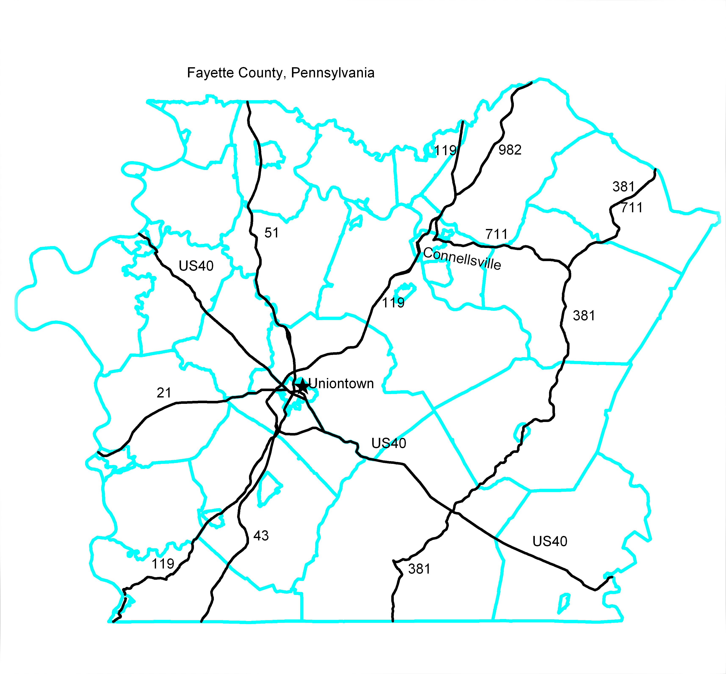
Figure 1

THIS PAGE IS INTENTIONALLY LEFT BLANK

APPENDIX 5 - POLITICAL SUBDIVISIONS THAT HAVE ADOPTED THIS PLAN AS THEIR OWN

The following political subdivisions have adopted this County plan as the plan for themselves. As such they will follow the procedures outlined in this plan, especially Paragraph III.E. Copies of any municipal resolutions adopting the plan are enclosed.

THIS PAGE IS INTENTIONALLY LEFT BLANK

FUNCTIONAL CHECKLISTS AND BLANK FORMS


Fayette County
Emergency Operations Plan

December 1, 2014

Volume III: Functional Checklists and Blank Forms

Copy Number _________

The contents of these Checklists are not subject to release under the provisions of Pennsylvania’s Right-To-Know Law.
The contents of these Checklists are not subject to release under the provisions of Pennsylvania’s Right-To-Know Law.

THIS PAGE IS INTENTIONALLY LEFT BLANK

ELECTED OFFICIALS

Responsible for: Protection of the county government, its citizens and their property
Reports to: The voters
DATE OF ACTIVATION: _______________ REASON FOR ACTIVATION: _____________________
Completed or N/A | By (initials) | Time | Item
 |  |  | Materials and Information Inventory
 |  |  | Copy of the County Emergency Operations Plan (EOP)
 |  |  | Notification and Resource Manual
 |  |  | Notification
 |  |  | Reported to the County Emergency Operations Center (EOC) at Fayette County EOC, 24 E Main Street Uniontown PA
 |  |  | Checklist reviewed
 |  |  | Established communication with other elected officials
 |  |  | Operations
 |  |  | Discussed the situation with the Emergency Management Coordinator
 |  |  | County’s response to the emergency monitored
 |  |  | Needs evaluated and resources committed as needed
 |  |  | Assumed role of Incident Commander
 |  |  | Delegated role of Incident Commander to _______________
 |  |  | Disaster Declaration
 |  |  | Determination made whether to declare a disaster emergency
 |  |  | Declaration prepared and signed by majority of the board of commissioners (see attachment to this checklist)
 |  |  | Declaration published by Public Information Officer
 |  |  | Copy of Declaration faxed to PEMA area office
 |  |  | Protective Actions
 |  |  | Recommendation made to the population to evacuate or to shelter, as needed
 |  |  | Continuity of Government
 |  |  | Chief Elected Official is: Vincent Zapatosky
 |  |  | Next in Line is: Angela Zimmerlink
 |  |  | Next in Line is: Alfred Ambrosini
 |  |  | In the absence of the above, responsibility for county government goes to : Chief County Clerk
 |  |  | Relocation of EOC
 |  |  | EOC staff and functions relocated to the alternate facility at the Fayette County EMA Annex at Joseph Hardy Connellsville Airport.
 |  |  | Important documents collected and transported to safe location at Fayette County EMA Annex.
 |  |  | Electronic documents “backed up” and the back-up transported to alternate location at Fayette County EMA Annex.
 |  |  | Recovery and Mitigation
 |  |  | Federal Recovery Programs
 |  |  | Appointed an “Applicant’s Authorized Agent“
 |  |  | Signed Notice of Intent to apply for federal aid
 |  |  | Mitigation
 |  |  | Modified land use/zoning plan
 |  |  | Enacted/enforced more stringent building codes
 |  |  | Constructed/maintained storm water management system
 |  |  | Improved public information about hazards

ATTACHMENT 1 - TO ELECTED OFFICIALS CHECKLIST

DECLARATION OF DISASTER EMERGENCY

WHEREAS, on or about __________ a (disaster) has caused or threatens to cause injury, damage, and suffering to the persons and property of Fayette County; and

WHEREAS, the (disaster) has endangered the health, safety and welfare of a substantial number of persons residing in Fayette County, and threatens to create problems greater in scope than Fayette County may be able to resolve; and

WHEREAS, emergency management measures are required to reduce the severity of this disaster and to protect the health, safety and welfare of affected residents in Fayette County:

NOW, THEREFORE, we, the undersigned Commissioners of Fayette County, pursuant to the provisions of Section 7501 of the Pennsylvania Emergency Management Services Code, (35 PA C.S., Section 7501), as amended, do hereby proclaim the existence of a disaster emergency in Fayette County

FURTHER, we direct the Fayette County Emergency Management Coordinator to coordinate the activities of the emergency response, to take all appropriate action needed to alleviate the effects of this disaster, to aid in the restoration of essential public services, and to take any other emergency response action deemed necessary to respond to this emergency.

STILL FURTHER, we authorize officials of Fayette County to act as necessary to meet the current demands of this emergency, namely: by the employment of temporary workers, by the rental of equipment, by the purchase of supplies and materials, and by entering into such contracts and agreements for the performance of public work as may be required to meet the emergency, all without regard to those time-consuming procedures and formalities normally prescribed by law, mandatory constitutional requirements excepted.

This Proclamation shall take effect immediately.

COMMISSIONERS

___________________________________
Chairman

___________________________________
Vice Chairman

___________________________________
Secretary

Attest:___________________________ Date:_________________

EOC MANAGER AND EMERGENCY MANAGEMENT COORDINATOR (EMC)

EOC Manager/Emergency Management Coordinator (EMC)
Responsible for: Overall emergency management program, activating and managing the

EOC Reports to: The Elected Officials
DATE OF ACTIVATION: _______________ REASON FOR ACTIVATION: _______________

Completed or N/A | By (initials) | Time | Item
 |  |  | Emergency Notification (Method: _______________)
 |  |  | Notification verified
 |  |  | Action Log Initiated
 |  |  | Elected officials notified
 |  |  | Increased readiness
 |  |  | Increased readiness received from Homeland Security Alert System (HSAS)
 |  |  | Watch/Warning received from National Weather Service (NWS)
 |  |  | Key staff placed on stand-by
 |  |  | Partial mobilization of EOC begun
 |  |  | EOC ACTIVATION
 |  |  | Materials Inventory
 |  |  | Copy of the County Emergency Operations Plan (EOP)
 |  |  | Copy of the State Emergency Operations Plan (SEOP)
 |  |  | Copy of affected municipality(ies) Emergency Operations Plan(s) (EOP)
 |  |  | Copy of EOC Checklists
 |  |  | Notification and Resource Manual
 |  |  | Action Log
 |  |  | Sign-In/Out Log (see Attachment 2 to this checklist)
 |  |  | Organization Chart
 |  |  | EOC floor plan sketch
 |  |  | Staff schedule for 24-hour operations (IAP for 2 shifts)
 |  |  | Action Status Board
 |  |  | Maps of the county
 |  |  | Office supplies
 |  |  | EOC ACTIVATED
 |  |  | EMC present at EOC at Fayette County EOC,24 E Main Street Uniontown PA
 |  |  | Deputy EMC notified/present
 |  |  | Elected official(s) notified/present (Name _______________)
 |  |  | Elected official(s) notified/present (Name _______________)
 |  |  | Elected official(s) notified/present (Name _______________)
 |  |  | Public Information Officer (PIO) notified
 |  |  | Operations Section Chief notified
 |  |  | Planning Section Chief notified
 |  |  | Logistics Section Chief notified
 |  |  | Admin-Finance Section Chief notified
 |  |  | Liaison Officer notified
 |  |  | Branch Director(s) notified for _______________ and _______________
 |  |  | Security in place
 |  |  | Status Board initiated
 |  |  | Message Log initiated
 |  |  | PEMA notified that EOC is operational
 |  |  | EOC Manager
 |  |  | Assumed responsibilities of IM/IC
 |  |  | Deferred the role of EOC Manager to _______________
 |  |  | Delegated the role of Operations Section Chief to _______________
 |  |  | Delegated the role of Planning Section Chief to _______________
 |  |  | Delegated the role of Logistics Section Chief to _______________
 |  |  | Delegated the role of Finance Section Chief to _______________
 |  |  | Communications
 |  |  | Phone lines tested
 |  |  | Radios tested
 |  |  | PaSTAR and SEVAN tested
 |  |  | Amateur Radio operator on site and operational
 |  |  | Emergency Alert System (EAS) station monitored. (Station ID: _______________)
 |  |  | Operations
 |  |  | EMC Initial Briefing on situation conducted
 |  |  | Follow-on briefings conducted at least hourly
 |  |  | Staff to maintain maps and status boards appointed
 |  |  | Maps posted with important information (affected area, Traffic Control Points (TCPs), Access Control Points (ACPs), evacuation routes, etc)
 |  |  | Contact established with neighboring counties, other counties in the RTF and with the PEMA Area office
 |  |  | Verified that affected local municipalities, schools, detention centers, health care facilities and other population concentrations have been notified and are aware of the situation
 |  |  | Protective action decision made by elected officials or EMC in their absence (Evacuation or Shelter in-place.)
 |  |  | Ensured the success of all Alert and Notification activities (route alerting, Siren-EAS activation, notification of the hearing impaired, including PIO activities and press releases), as appropriate
 |  |  | Ensure that Resource Request Status Log (see Attachment 3 to this checklist) is utilized
 |  |  | EOC Relocation
 |  |  | Alternate Site Open at EMA Annex,Joseph A Hardy Connellsvillie Airport
 |  |  | Equipment & logs packed
 |  |  | PEMA (Area office) notified
 |  |  | EOCs notified in adjoining counties and the RTF
 |  |  | Responders notified
 |  |  | Security in place (Sign-in / Sign-out)
 |  |  | EOC OPERATIONS
 |  |  | Elected Officials and EOC staff informed when things change
 |  |  | Verification complete that schools, businesses and other population concentrations are aware of the problem
 |  |  | Available resources monitored
 |  |  | Requirements reviewed and “unmet needs” reported to PEMA
 |  |  | Route alerting accomplished (Firefighting Branch)
 |  |  | Periodic briefing of the county EOC conducted
 |  |  | Established a “victim accountability system” to track missing citizens who are forced to leave their homes
 |  |  | Worked with ESF #6 branch to identify location of displaced victims
 |  |  | PROTECTIVE ACTIONS
 |  |  | Protective Action Decision made by elected officials (EMC in their absence)
 |  |  | Shelter in Place Recommended
 |  |  | Evacuation Recommended
 |  |  | Shelter in Place
 |  |  | PIO Notified
 |  |  | Public announcement and instructions prepared
 |  |  | Non-English speaking citizens addressed
 |  |  | Announcement broadcast over EAS
 |  |  | Route alerting conducted (if appropriate)
 |  |  | Mass Care Shelter
 |  |  | ESF #6 contacted to set up mass care shelter
 |  |  | Shelter Manager appointed
 |  |  | Shelter open and operational
 |  |  | PIO announced location of temporary shelter
 |  |  | Evacuation
 |  |  | Verified adequacy of resources for evacuation including special equipment for the mobility impaired and provisions for pets
 |  |  | Ensured that Mass Care, Evacuation and Sheltering issues are adequately addressed
 |  |  | Routes and other parameters (when, who, how many, to where) of the evacuation planned
 |  |  | Sirens and EAS (if practical) sounded
 |  |  | Non-English speaking citizens addressed
 |  |  | Assistance provided for mobility impaired residents
 |  |  | Reviewed Traffic Control Points (TCPs) and Access Control Points (ACPs) for police in emergencies (Public Safety and Security (ESF #13) Branch)
 |  |  | Verified that Route/Sector Alert Teams completed their assignments in local municipalities
 |  |  | Verified that local municipalities have up-to-date lists of hearing impaired and special notification residents
 |  |  | Verified that local municipalities have up-to-date lists of non-ambulatory residents requiring ambulance assistance to evacuate
 |  |  | Reviewed transportation planning. (Transportation (ESF #1) Branch)
 |  |  | Reviewed “unmet needs” of the municipalities (ESF #7)
 |  |  | Verified that emergency fuel supplies, towing and repair services are available for evacuees
 |  |  | Reviewed communication capabilities to maintain contact with local EOCs, TCPs and ACPs, Transportation Pickup Points and buses and Route/Sector Alert Teams (ESF #2)
 |  |  | Verified notification of major businesses and industries, camp sites, motels/hotels, and other transient sites once the siren alert sounded (Communications (ESF #2) Branch)
 |  |  | Provided for sufficient buses and/or other transportation to pick up those residents without means of transportation (Transportation Branch)
 |  |  | Evaluated selected TCPs and determined suitability and adequacy as evacuation routes (Public Safety and Security Branch)
 |  |  | Monitored the process
 |  |  | After citizens have evacuated, relocated the EOC (if necessary)
 |  |  | Notified PEMA when evacuation complete
 |  |  | Damage Reporting and Assessment
 |  |  | Collected and tabulated damage reporting data from local municipalities
 |  |  | Ensured that county Damage Assessment teams have sufficient supplies
 |  |  | Notified Damage Assessment Team leaders and placed them on alert
 |  |  | Obtained vehicles to conduct damage assessment
 |  |  | Coordinated radios to conduct damage assessment with ESF #2
 |  |  | Assembled all damage reporting personnel and dispatched in teams
 |  |  | Established a telephone number for call-in and established reporting time frames
 |  |  | Reviewed damage reporting plan and listed the “unmet needs”
 |  |  | Assign Damage Assessment Teams (minimum of two individuals) to conduct an initial damage survey
 |  |  | Assigned one member of the Damage Reporting Team, who is familiar with the location of the damage, to accompany each Federal/State Damage Assessment Team (as necessary)
 |  |  | Reviewed damage reporting plan and listed the “unmet needs”
 |  |  | Compile Damage Survey Reports and forward same to PEMA
 |  |  | Maintain records of all expenditures related to damage assessment activities and submitted to the requesting authorities
 |  |  | Disaster Declaration
 |  |  | Assisted Elected Officials in preparation of the disaster proclamation document (see Elected Officials Checklist)
 |  |  | Obtained signature of a majority of the membership of the board of elected officials
 |  |  | Sent (faxed) copy of proclamation to PEMA
 |  |  | DISASTER RECOVERY OPERATIONS
 |  |  | Federal Recovery Programs
 |  |  | Maintained records to document expenditures by the municipality
 |  |  | Assisted PEMA in establishing a Disaster Recovery Center (DRC)
 |  |  | Issued a news release urging citizens and businesses to register with FEMA
 |  |  | Returning evacuees and recovery
 |  |  | Adequate supplies of food arranged
 |  |  | Adequate supplies of fuel arranged
 |  |  | Assisted public utility with finding and repairing utility outages
 |  |  | Notified evacuees of status of return
 |  |  | Reviewed project listing in Hazard Mitigation Plan for projects that might prevent, or lessen the impact of re-occurrence of the emergency
 |  |  | Checked with county before closing the EOC Log, and the EOC
 |  |  | Develop an After Action Report (AAR) for the Incident
 |  |  | AAR conducted and written IP distributed to participants
 |  |  | Follow-up on accomplishment of IP recommendations
 |  |  | Incorporated lessons learned during emergencies or exercises into the existing plan and procedures

PUBLIC INFORMATION OFFICER (PIO) - (External Affairs - ESF 15)

Public Information Officer (PIO) External Affairs (ESF #15)

Responsible for: Coordination with news media outlets, preparing press releases, public inquiry
Reports to: The EOC Manager (Emergency Management Coordinator)
ESF Coordinating Agency _______________________________
DATE OF ACTIVATION: ______________REASON FOR ACTIVATION: ______________________

Completed or N/A | By (initials) | Time | Item
 |  |  | Materials and Information Inventory
 |  |  | Copy of the County Emergency Operations Plan (EOP)
 |  |  | Copy of this checklist
 |  |  | Notification and Resource Manual
 |  |  | Copies of necessary Emergency Support Function-specific emergency manuals, plans, procedures, and other reference materials
 |  |  | Action Log
 |  |  | Listing of area news media
 |  |  | Notification
 |  |  | Reported to the Emergency Operations Center (EOC) at Fayette County EOC,24 E Main Street Uniontown PA 15401
 |  |  | Reviewed the checklist
 |  |  | Notified the Deputy Public Information Officer and placed him/her on standby
 |  |  | Opened and maintained ESF #15 Action Log (see Attachment 1)
 |  |  | Developed shift schedule for possible 24-hour operations
 |  |  | Established contact with the Adjacent County Public Information Officers and PEMA PIO
 |  |  | Notified Emergency Management Coordinator (EMC) of “unmet needs” in External Affairs
 |  |  | Reviewed hazard information relevant to the emergency
 |  |  | Ensured that the Emergency Alert System (EAS) contained in ESF #2, is included as a part of the system for disseminating emergency public information
 |  |  | Ensured that Emergency Public Information (EPI) materials are available for handicapped, visually impaired, hearing impaired, and non-English speaking populations as well as for the general public
 |  |  | OPERATIONS
 |  |  | When two or more municipalities are involved, requested all public information be coordinated with the County PIO/JIC
 |  |  | Designated location for the County PIO/JIC
 |  |  | Kept the EOC Manager informed of External Affairs status
 |  |  | Prepared to relocate if necessary
 |  |  | Assisted with collecting, completing and forwarding damage reports and assessments
 |  |  | If requested by EOC Manager, established and staffed public inquiry line – reported patterns and recurring rumors to the EMC
 |  |  | Coordinated with all EOC staff sections for the latest information on the status of their operations
 |  |  | Monitored media coverage of the emergency
 |  |  | Responded to the Joint Information Center (w/other municipalities or the county) as needed
 |  |  | Provided technical assistance, as requested
 |  |  | Provided situation reports of ESF #15 activities to EOC supervisor/EMC, as required
 |  |  | Requested state/federal resources, as needed
 |  |  | Sent representative to state or federal JIC, if one is established
 |  |  | Established procedures for and supervised any visits from VIPs or other elected officials
 |  |  | Authenticated sources of information and had the Chief Executive or EMC clear all public announcements
 |  |  | Public Information
 |  |  | Established “Emergency Information Hotline”
 |  |  | Identified and responded to specific emergency information needs of affected communities
 |  |  | Provided emergency information relevant to special needs populations
 |  |  | Consulted Behavioral Health regarding the wording of all releases
 |  |  | Posted disaster information on a county or EMA-owned website
 |  |  | Contacted special interest groups (churches, social/fraternal, agency on aging, non English speaking, etc) to get disaster information to their constituents
 |  |  | Provided accurate and reliable information regarding areas which have been evacuated, and the destination of the evacuees
 |  |  | Provided accurate and reliable information regarding deaths, injuries, illness, and missing to family members in a timely manner
 |  |  | Provided the address, telephone number, and location of emergency shelters to the public
 |  |  | News Media
 |  |  | Established a media reporting area for the PIO and chief elected official to meet with news media
 |  |  | Scheduled and conducted media briefings on a regular basis
 |  |  | Prepared and disseminated news releases to the media
 |  |  | News Releases
 |  |  | Used pre-formatted releases if practical. (See Attachment 2 to this checklist)
 |  |  | EOC Manager informed of the public information status
 |  |  | Recommended that victims contact their insurance carrier
 |  |  | Notified evacuees of status of return
 |  |  | Provided special instructions, including information relevant to recovery
 |  |  | Provided information to the public regarding disaster assistance available and how it can be accessed
 |  |  | Continued to provide emergency public information relevant to recovery
 |  |  | Assessed effectiveness of information and education programs
 |  |  | Attended AAR and implemented IP recommendations that apply to PIO or External Affairs

ATTACHMENT 2 - TO PIO CHECKLIST

SAMPLE RADIO/TV MESSAGES

ROADS CLOSED
This is an emergency notification from the Fayette County Emergency Management Agency. The recent storm has caused (disaster) in many areas. As of (time) today, law enforcement officials closed the following roads/streets:

1. All of River Road within ________________City/Township/Borough.
2. (LOCATION)
3. (LOCATION)
Please avoid these roads/streets. If you must travel, use alternate routes.

Again, those roads/streets that have been closed are:
1. __________________________________________________________________
2. __________________________________________________________________
3. __________________________________________________________________
Please stay tuned to this station for additional road closure information.

EVACUATION RECOMMENDATION
The following announcement has been released by the __________ Emergency Management Agency:

The flooding continues and may worsen. For your safety, the (elected officials) recommend(s) that you leave the ________________________ area as soon as possible (give boundaries of local area, evacuation routes).

Be sure to take essential items--medicine, special foods, personal items, baby supplies, clothing, money and valuable papers--but do not overload your car. Secure your home before you leave. Be sure to check on any neighbors who may need assistance.

If you cannot stay with relatives or friends outside of the evacuation area, go to (one of) the Red Cross shelter(s) located at________________________________.

If you have no means of transportation or if you are physically unable to evacuate on your own, ask a neighbor to assist you or call _______________. Otherwise, please do not use your telephone except to report an emergency.

I repeat. If you live in the _________________________ area (give boundaries), you are requested/required to evacuate for your own safety. Stay tuned to this station for more information and instruction

LIAISON OFFICER CHECKLIST

Liaison Officer
Responsible for: Assisting and cooperating with agency representatives from outside agencies, including government, private organizations or voluntary organizations.

Reports to: The EOC Manager
DATE OF ACTIVATION: _______________REASON FOR ACTIVATION: ______________
Completed or N/A | By (initials) | Time | Item
 |  |  | Assumed responsibilities of the Liaison Officer
 |  |  | Developed list of all outside agencies involved in the response (those beyond normal responders)
 |  |  | Established contact with outside agencies and made self available for liaison with each outside agency
 |  |  | Coordinated intergovernmental cooperation
 |  |  | Identified location for agency representatives from outside agencies to work in or near the EOC
 |  |  | Identified and attempted to resolve problems or complaints arising between agencies involved in the response
 |  |  | Ensured agency representatives can access their respective agencies’ information networks while in the County EOC or in the field
 |  |  | Incorporated lessons learned during emergencies or exercises into the existing plan and procedures

DAMAGE ASSESSMENT PROCESS

DAMAGE ASSESSMENT PROCESS

The following procedures have been developed by PEMA to describe the procedures to be followed in gathering information to support a request for a Presidential Declaration under the provisions of the Robert T. Stafford Disaster Relief and Emergency Assistance Act.

Step 1

Incident occurs: An incident occurs that has the potential for a Presidential Declaration for Individual Assistance, Public Assistance or both. Examples would be flooding, adverse weather, civil unrest, major fires, etc.

Reporting: The incident is reported to the County 9-1-1 Center. The 9-1-1 Center notifies the appropriate organizations as well as the County emergency management agency. If necessary, the affected municipality(ies) may declare a disaster emergency by securing signatures from a majority of the elected officials on a disaster declaration. The subject disaster declaration is then forwarded to the next level of government and eventually to the State emergency operations center (EOC).

Municipal Damage Reporting/IDR: Title 35 requires political subdivisions to “provide prompt and accurate information regarding local disaster emergencies to appropriate Commonwealth and local officials and agencies and the general public”. Information provided generally includes the location of the damaged property, as well as the extent of damage (i.e., destroyed, major, minor, affected or inaccessible). This damage reporting should be accomplished using paper or electronic forms that can be hand carried, faxed or emailed to the County EOC. Provided the jurisdiction has been given the authority to do so by the county, this step may include the submission of data into the PEMA initial damage reporter (discussed later). If not, the County ESF #5 will enter information into the PEIRS IDR. As more detail becomes available, the PEIRS IDR will be updated.

Step 2

County Damage Assessment (Initial Damage Assessment): The county damage assessment team will evaluate damaged locations, as provided by municipal emergency management coordinator (EMC)/municipality, to determine the actual effects of a disaster. This information is collected using paper damage assessment forms. The county team may be augmented by PEMA staff from the Area office.

- Damages to homes and businesses: An individual Damage Assessment Field Worksheet (See Blank Forms, page 93) is completed on every property affected. Each property is then placed in one of five possible damage categories: destroyed, major damage, minor damage, affected or inaccessible.

- Damages to infrastructure: An individual damage assessment form is completed on all damaged infrastructure and subsequently categorized into one of three damage categories including: destroyed, damaged or affected. An actual cost estimate is required for infrastructure damage using a separate cost calculator. The cost estimate shall be included on the paper damage report.

- Using the information collected in the previous steps, the county damage assessment team, in conjunction with the county EOC will enter the data into the PEMA initial damage reporter (IDR) program, as required.

- The County Commissioners may also sign a disaster declaration by securing signatures from a majority of the Commissioners. The subject declaration shall be forwarded to the State emergency operations center (EOC).

Step 3

State Emergency Operations Center: Personnel from the Bureau of Recovery and Mitigation (BORM) will extract and analyze the information contained in the IDR program to determine if a State Disaster Declaration is necessary and to determine if sufficient damage exists to warrant Federal assistance.

- If necessary, BORM will coordinate with FEMA Region III to conduct a joint preliminary damage assessment (JPDA). They will also coordinate, through the respective PEMA Area Offices, a date and time for a JPDA to be conducted in the affected counties (see below). The JPDA teams can consist of personnel from the local affected jurisdiction, the county, the respective PEMA Area Office, BORM, PennDOT, DEP, SBA, FEMA Individual Assistance and/or Public Assistance officials, as well as others. The JPDA is scheduled as soon as practical during the beginning of the recovery process.

- If a State Disaster Declaration is warranted, the PEMA Attorney, in conjunction with the Executive Office will write the declaration for the Governor’s signature.

Step 4

Joint Preliminary Damage Assessment (JPDA): PDAs for Individual Assistance and Public Assistance are conducted separately.

- For Individual Assistance, the joint PDA team usually consists of representatives from FEMA, the respective PEMA Area Office (and/or headquarters), SBA, the affected County and municipality. The County or municipal EMC must prepare and have available a map showing all damaged property with a suggested survey route clearly marked, beginning with the worst damages first.

- For Public Assistance, the joint PDA team usually consists of representatives form FEMA, FEMA Hazard Mitigation, the respective PEMA Area Office (and/or headquarters), PennDOT, DEP, the affected County and municipality. The County or municipal EMC must prepare and have available a map showing all damaged infrastructure with a suggested survey route clearly marked, beginning with the worst damages first.

- When the IA or PA joint PDA is completed, team members (PEMA, FEMA, SBA, etc.) will fax, email or phone in the results to the appropriate agencies (State EOC, FEMA Region III, SBA, etc.)

Step 5

Analysis of Data by BORM: After receiving the JPDA team summary information, BORM conducts an analysis of the results along with any data entered into the IDR to determine if sufficient thresholds have been reached to warrant a Federal declaration. If so, BORM will draft a letter for the Governor’s signature that will be forwarded to the President, requesting Federal assistance.

Step 6

BORM drafts letter and forwards to Governor for signature

Step 7

Governor’s Request to FEMA

Step 8

FEMA’s Recommendation

Step 9

White House Review

Step 10

Presidential Action

Damage Assessment Process

SBA

Step 1

Incident occurs: An incident occurs that has the potential for a Presidential Declaration for Individual Assistance, Public Assistance, Small Business Administration (SBA) or combination of the three. Examples would be flooding, adverse weather, civil unrest, major fires, etc.

Reporting: The incident is reported to the County 9-1-1 Center. The 9-1-1 Center notifies the appropriate organizations as well as the County emergency management agency. If necessary, the affected municipality(ies) may declare a disaster emergency by securing signatures from a majority of the elected officials on a disaster declaration. The subject disaster declaration is then forwarded to the next level of government and eventually to the State emergency operations center (EOC).

Municipal Damage Reporting: Title 35 requires political subdivisions to “provide prompt and accurate information regarding local disaster emergencies to appropriate Commonwealth and local officials and agencies and the general public”. Information provided generally provides the location of the damaged property, as well as the extent of damage (i.e., destroyed, major, minor, affected or inaccessible). This damage reporting should be accomplished using paper or electronic forms that can be hand carried, faxed or emailed to the County EOC. Provided the jurisdiction has been given the authority to do so by the county, this step may include the submission of data into the PEMA initial damage reporter (discussed later).

Step 2

County/PEMA Damage Assessment (Initial Damage Assessment): The county damage assessment team will evaluate damaged locations, as provided by municipal emergency management coordinator (EMC)/municipality, to determine the actual effects of a disaster. This information is collected using paper damage assessment forms. The county team may be augmented by PEMA staff from the Area office.

- In conjunction with the county EMC and the county damage assessment team, PEMA will determine if sufficient damage exists to warrant an IA/PA declaration. In this case, the IA/PA track will be followed.

- If insufficient damage exists for a Presidential declaration, then the SBA track will be followed. Information will be collected for either a SBA physical damage declaration, Economic Injury Disaster Loan (EIDL) declaration, or both.

- A Small Business Administration workshop will be set up to collect information from residents and businesses. County and PEMA Area Office staff will conduct this workshop either from a physical location where residents and businesses can come to provide damage information or via a walking tour of the damaged area where staff talk with the residents and business owners to gather information. Either a physical disaster worksheet or an EIDL worksheet is completed for each damaged property or business.

- All individual sheets completed and collected are sent to the State EOC with copy to BORM.

Step 3

State Emergency Operations Center: Personnel from the Bureau of Recovery and Mitigation (BORM) will extract and analyze the information contained in the worksheets to determine if a State Disaster Declaration is necessary and to determine if sufficient damage exists to warrant a Small business Administration Declaration. When and if BORM determines that sufficient damages are present for either a Physical Damage or EIDL Declaration, they will process the necessary documentation and forward to the SBA.

Step 4

BORM

BLANK FORMS

The forms provided here are to support and document the activities outlined in the checklists. Recognizing that the needs of each county differ, the use of these particular forms is not mandatory. But it is strongly recommended.

As Pennsylvania moves toward totally integrating the Incident Command System (ICS) and the National Incident Management System (NIMS), a large part of the standardization that is a hallmark for these systems will be reflected in the use of standardized forms. As standardized forms are developed and implemented, they will be distributed for the use of all emergency responders.

A first step in this process is the Unit Log (ICS 214) that in included as a form of Action Log. This form is designed for each unit, branch, section or even individual, in that it leaves space for a list of those persons who contribute to the efforts it describes, and their position in the organization. It provides space to record major activities, and serves the role of an EOC log - the second (and subsequent) page(s) are completely devoted to activity log. You will note that the ICS 214 has a place for the Operational Period, indicating that a new unit log should be started every shift.

THIS PAGE IS INTENTIONALLY LEFT BLANK

EOC INCIDENT MESSAGE FORM

Incident No: __________
Message No: __________
Time: _______________

FROM: Name ______________________
Address ________________________________________
Municipality _________________ Telephone _________________ Date ___________
MESSAGE:_________________________________________________________________________________________________________________________________________________

SECTION CHIEF AND ESF ROUTING INFORMATION:
Action | Info |  |  |  | Action | Info |  |  |  | Action |  |  | Info
COMMAND |  |  | OPERATIONS |  |  |  |  |  | LOGISTICS
Elected Official  A  I |  |  | Communications (2)  A  I |  |  |  |  |  | Transportation (1)  A  I
EMC  A  I |  |  | Firefighting (4)  A  I |  |  |  |  |  | Public Works and Engineeringing (3)  A  I
Public Information (15)  A  I |  |  | Public Health and Medical Services (8)  A  I |  |  |  |  |  | Mass Care, Shelter, and Human Services (6)  A  I
County Department Head  A  I |  |  | Search and Rescue (9)  A  I |  |  |  |  |  | Resource Support (7)  A  I
Liaison Officer  A  I |  |  | Hazardous Materials (10)  A  I |  |  |  |  |  | Agriculture and Natural Resources (11)  A  I
 |  |  | Public Safety and Security (13)  A  I |  |  |  |  |  | Energy (12)  A  I
Action | Info |  |  |  |  | Action |  | Info
PLANNING |  |  |  | FINANCE/ADMINISTRATION
Emergency Management (5)  A  I |  |  |  | Finance  A  I
Administration
A
I
Long Term Recovery and Mitigation (14)
A
I

ACTION TAKEN:
__________________________________________________________________________________________________________________________________________________________________________________________________________________________________________________________________________________________________________________________________________________________________________________________________________________________________________________________________

OPEN CLOSED (TIME: ________ Initials: ________) A = Action I = Information
Section Chief Copy ___
LOG Copy ___
EOC Mgr Copy ___
ESF Copy ___
Close Out Copy ___

MESSAGE LOG

MESSAGE LOG |  |  |  |  |  |  |  |  | Page _____  Of _____
Date | TIME | In | Out | METHOD | SUBJECT | TO | FROM | DISTRIBUTION

INCIDENT CHECK-IN LIST - ICS form 211

INCIDENT CHECK-IN LIST - ICS form 211
1. Incident Name |  | 2. Check-In Location |  | 3. Date/Time
 |  | ________ County EOC
Position Assignment |  |  | Name  (Please Print Clearly) |  | County Staff (Y/N) |  |  | Date/Time Check-In |  | Signature | Date/ Time Check-Out
EOC Manager
 | Deputy EOC Manager
 | PIO
 | Liaison Officer
 | Safety Officer
 | Agency Rep
 | Agency Rep
 | Agency Rep
Operations Section Chief
 | Communications (ESF #2) Branch Lead
 | Firefighting (ESF #4) Branch Lead
 | Public Health & Med Services (ESF #8) Lead
 | Search & Rescue (ESF #9) Lead
 | Oil & HAZMAT (ESF #10) Lead
 | Public Safety & Security (ESF #13) Lead
Planning Section Chief
 | Emergency Management (ESF #5) Branch Lead
Logistics Section Chief
 | Transportation (ESF #1) Branch Lead
 | Public Works (ESF #3) Branch Lead
Page 1 of ____ |  |  |  |  | 5. Prepared by (Name and Position) Use back for remarks or comments

INCIDENT CHECK-IN LIST - ICS form 211
1. Incident Name |  | 2. Check-In Location |  | 3. Date/Time
 |  | ________ County EOC
Position Assignment |  |  | Name  (Please Print Clearly) |  | County Staff (Y/N) |  | Date/Time Check-In |  | Signature | Date/ Time Check-Out
 | Mass Care, Shelter and Human Services (ESF #6) Branch Lead
 | Resource Support (ESF #7) Branch Lead
 | Agriculture and Natural Resources (ESF #11) Branch Lead
 | Energy (ESF #12) Branch Lead
Finance and Administration Section Chief
 | Long Term Recovery and Mitigation (ESF #14) Branch Lead
Page 2 of ____ |  |  |  |  | 5. Prepared by (Name and Position) Use back for remarks or comments

ICS 214

 | ICS 214
UNIT LOG |  |  |  | 1. Incident Name |  |  |  | 2. Date Prepared |  |  |  |  | 3. TIME
Unit Name/Designators |  |  |  |  | Unit Leader (Name and Position) |  |  |  |  | 5. Operational Period |  |  | From
 |  |  |  |  |  |  |  |  |  | Date |  |  | To
7. Personnel Roster Assigned
Name |  |  |  |  |  | ICS Position
8. Activity Log
TIME |  |  | Activity
Prepared By:

 | ICS 214 (Page 2)
UNIT LOG |  |  |  | 1. Incident Name |  | 2. Date Prepared |  |  |  | 3. TIME
8. Activity Log (Cont)
TIME
Prepared By:

PEMA RESOURCE REQUEST FORM

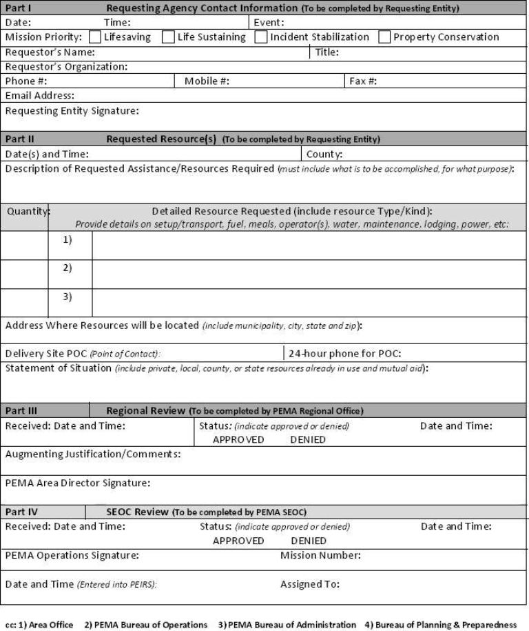
Figure 2

RESOURCE REQUEST STATUS LOG (name of municipality)

RESOURCE REQUEST STATUS LOG (name of municipality)
Page _____
Of _____
Resource  Request # | Resource | Date/TIME of Request | Date/TIME Forwarded to County | Approved/ Disapproved | Date/TIME notified of (dis)approval | Comments | Date Delivered | Date Returned

INITIAL DAMAGE REPORT WORKSHEET

INITIAL DAMAGE REPORT WORKSHEET

Name of Event: Date:

County: ____________ Municipality: ___________________ TIME of Report: _______

Disaster Declared: Yes/No Date & TIME: ______ EOC Activated: Full/Partial/None TIME: _

Person Completing This Report: ________________________ Phone No: ___________

Casualties Damages
IA Destroyed Major Minor Affected Inaccessible

Fatalities _______ Single Family ______ _____ ______ ______ _______

Major Injuries _______ Multi-Family ______ ______ ______ ______ _______

Minor Injuries _______ Mobile Homes ______ ______ ______ ______ _______

Missing _______ Businesses ______ ______ ______ ______ ______

Human Impact PA Destroyed Major Minor

No. Hospitalized _______ Fire/EMS Facility ______ ______ _____

Evacuated _______ Hospital ______ ______ _____

No. Sheltered _______ Nursing Home ______ ______ _____

Park _____ ______ _____

Comments: _________________________________ Power Supply _____ ______ _____

___________________________________________ Public Building _____ ______ _____

___________________________________________ Road _____ ______ _____

___________________________________________ Sanitary Sewer _____ ______ _____

___________________________________________ School _____ ______ _____

__________________________________________ Sewer Plant _____ ______ _____

___________________________________________ Storm Sewer _____ ______ _____

___________________________________________ Water Control Facility_____ ______ _____

___________________________________________ Water Supply _____ ______ _____

___________________________________________ Water Treatment _____ ______ _____

___________________________________________ Bridges & Culverts ______ ______ _____

___________________________________________ Other ______ ______ _____

__________________________________________ Debris Removal Yes/No
Emergency Protective Measures Yes/No

(Map attached – and/or Addresses and/or GPS Coordinates)
COUNTY: __________________________ MUNICIPALITY: ___________________
NAME :__________________________________
STREET ADDRESS:_______________________ Yes No
CITY: ___________________, PA, ZIP: _______ Primary Home
LONGITUDE: _________LATIDUDE:_________ Renter

INDIVIDUAL ASSISTANCE FORM 2

Disaster Damage Assessment
Field Worksheet - Individual Property
COUNTY: |  |  |  |  | MUNICIPALITY:
NAME:
STREET ADDRESS:
CITY: |  |  |  |  |  | PA, ZIP
CODE: |  |  |  |  |  | Date:
LONGITUDE: |  |  |  |  | LATITUDE:
Location Notes: |  |  |  |  |  |  | Yes | No
 |  |  |  |  |  | Primary Home
 |  |  |  |  |  | Renter
SYSTEM |  | DAMAGED |  | % R.C. |  | DAMAGE CATEGORY
 |  | Home | Mobile Home | Home | Mobile Home |  | Home | Mobile Home
Foundation |  |  |  | 7 |  | Destroyed
Floor (Frame) |  |  |  | 16 | 20 | Major
Exterior Walls |  |  |  | 14 | 35 | Minor
Roof |  |  |  | 9 | 20 | Affected
Interior Walls |  |  |  | 28 | 25 | Inaccessible
 |  |  |  |  |  | NOTE: Non-observable refers only to a visual inspection from the dwelling exterior. These systems can be observed if you are able to walk through the dwelling.
Pumbing |  |  |  | 10
Heating/A.C. |  |  |  | 10
Electrical |  |  |  | 6
Total % Damaged
X Estimated Replacement Cost |  |  |  |  |  | =
= Estimated Structural Damage |  |  |  |  |  | $
+ Estimated Damage to Contents |  |  |  |  |  | $
= Total Estimated Damage |  |  |  |  |  | $ | $0.00
COMMENTS: |  |  |  |  |  |  | Yes | No
 |  |  |  |  | Flood Insurance
 |  |  |  |  | Basement Water**
 |  |  |  |  | First Floor Water**
 |  |  |  |  | **Height Water (Inches):
Additional comments
NAME OF ASSESSOR:
DATE:

DISASTER DAMAGE ASSESSMENT - PUBLIC PROPERTY

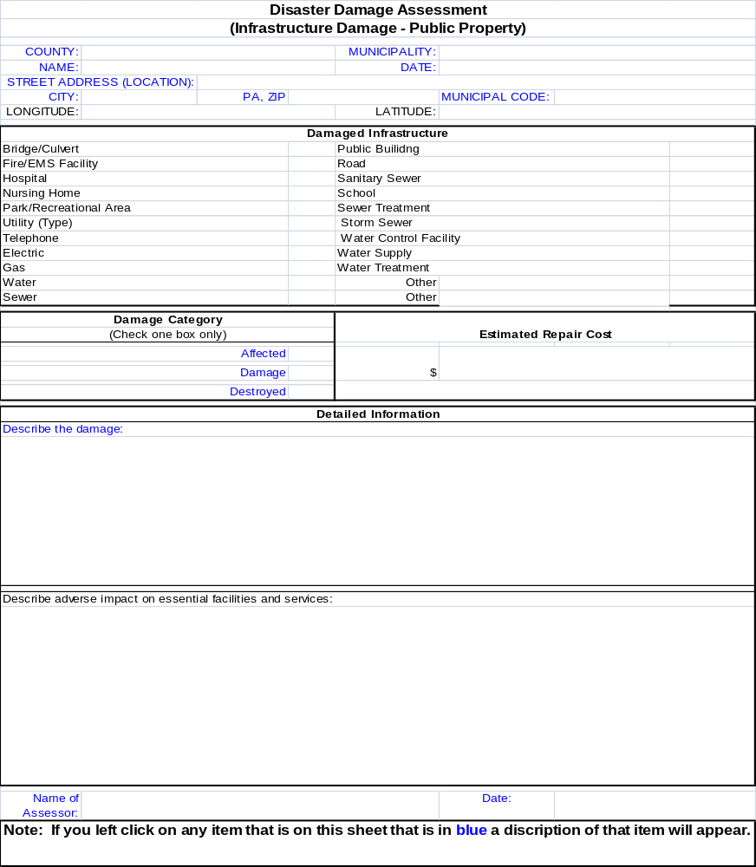
Figure 3

MUNICIPALITY - COUNTY INITIAL DAMAGE REPORT (IDR) WORKSHEET

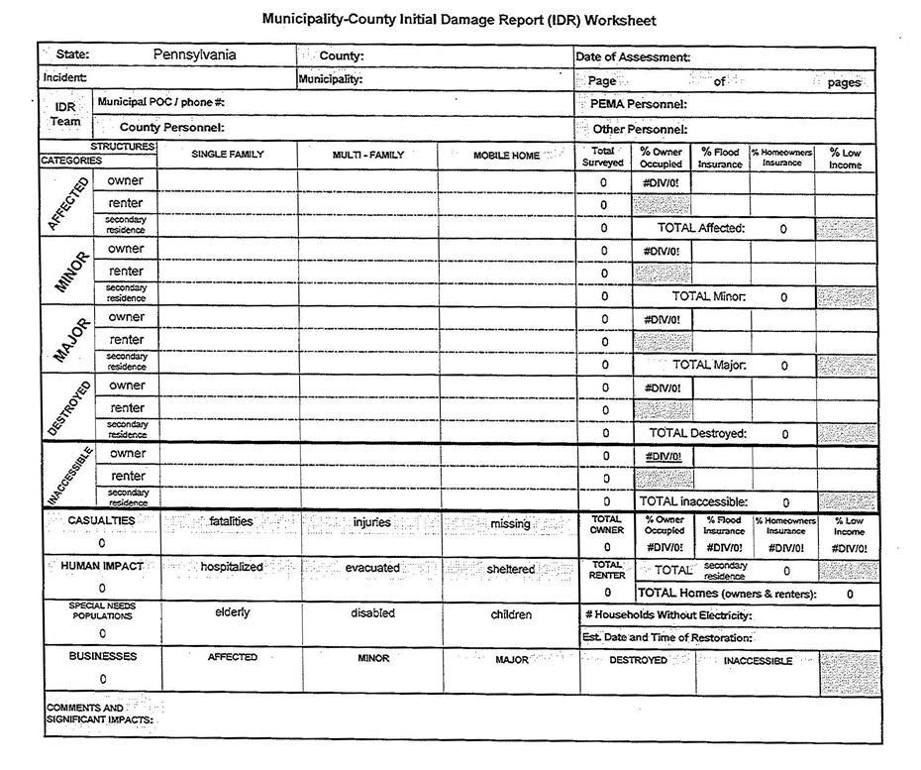
Figure 4

DAP 19 - LOCAL DAMAGE ASSESSMENT FORMS

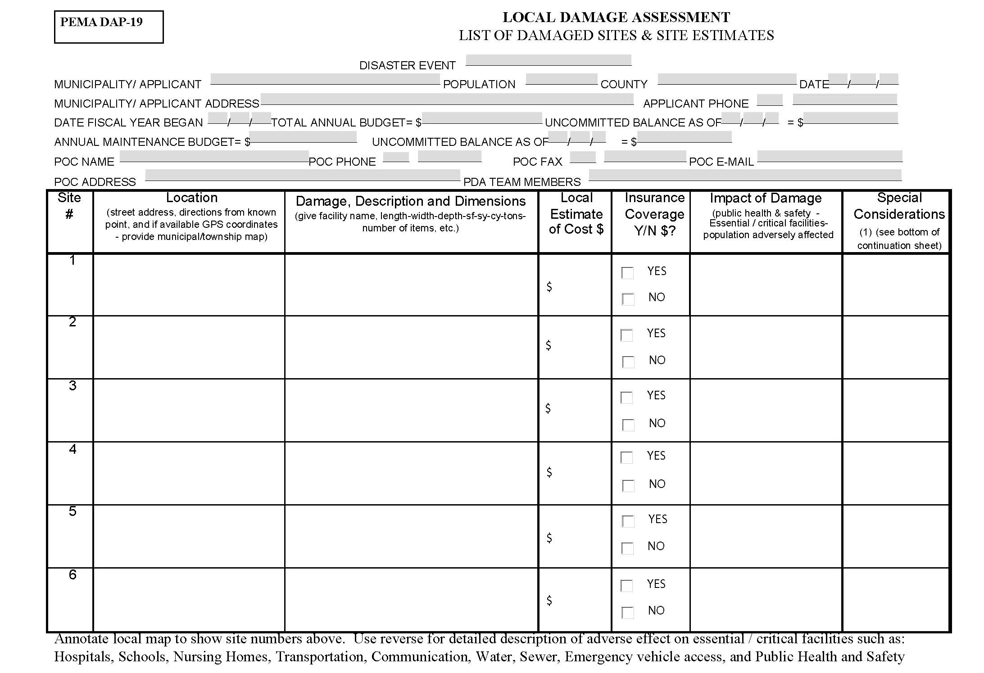
Figure 5
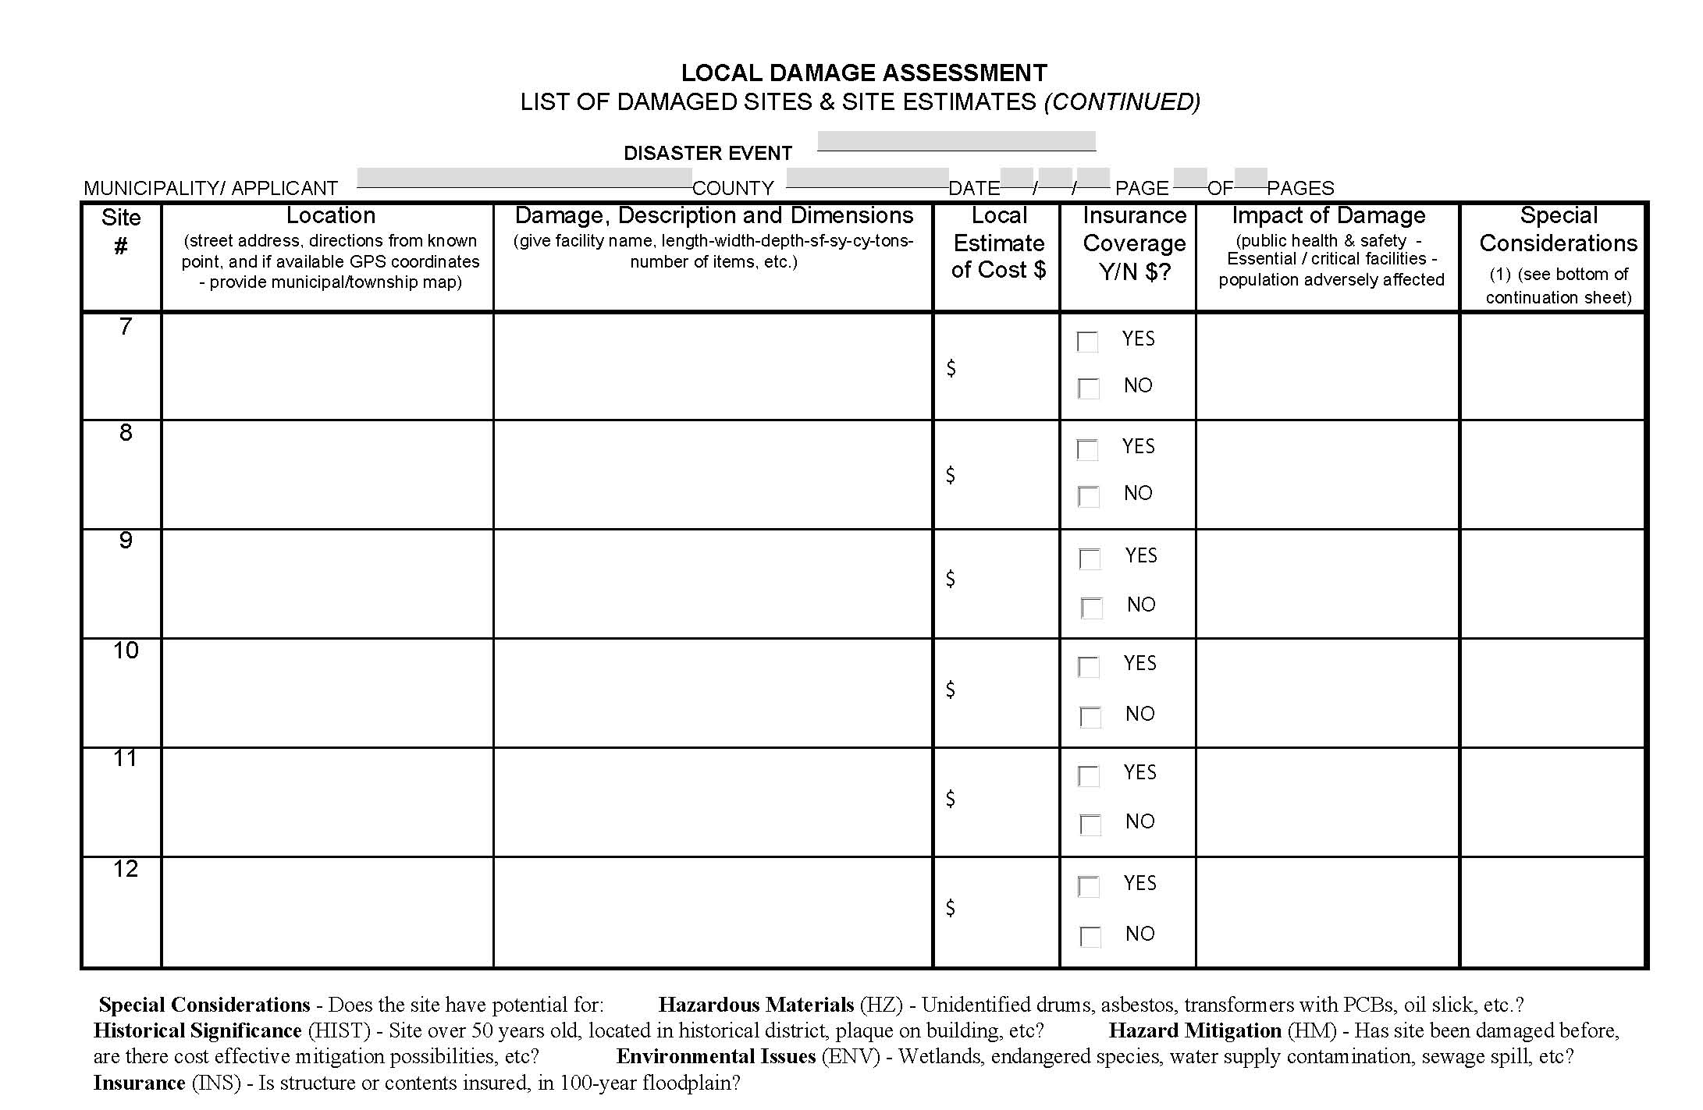
Figure 6
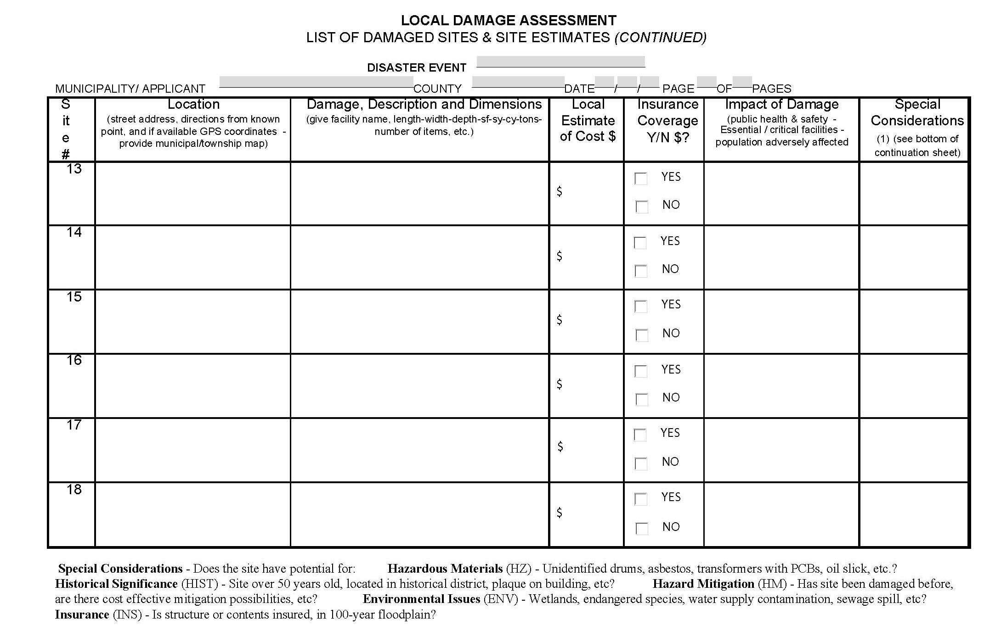
Figure 7

INDIVIDUAL ASSISTANCE DAMAGE DEFINITIONS

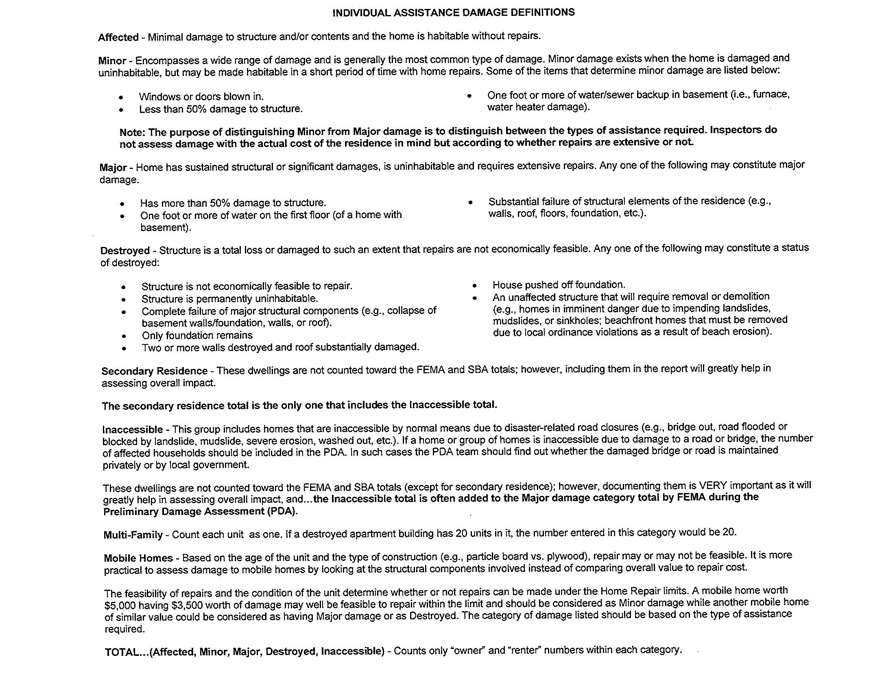
Figure 8

SBA CONSOLIDATED FORMS

PDL Survey

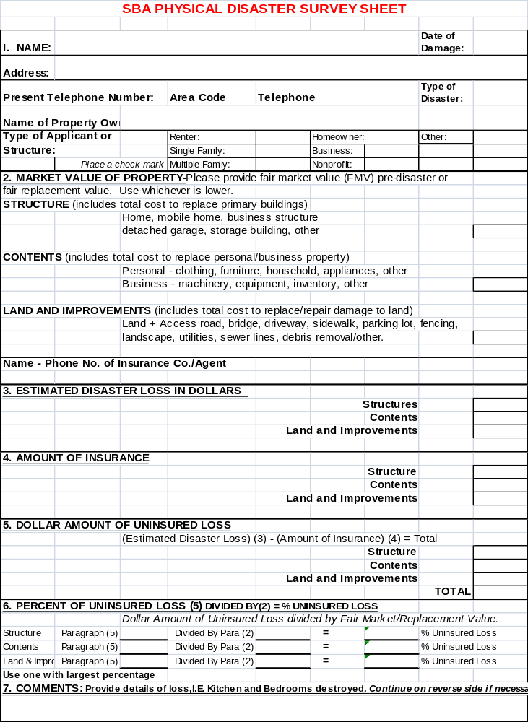
Figure 9

PDL Sample Survey

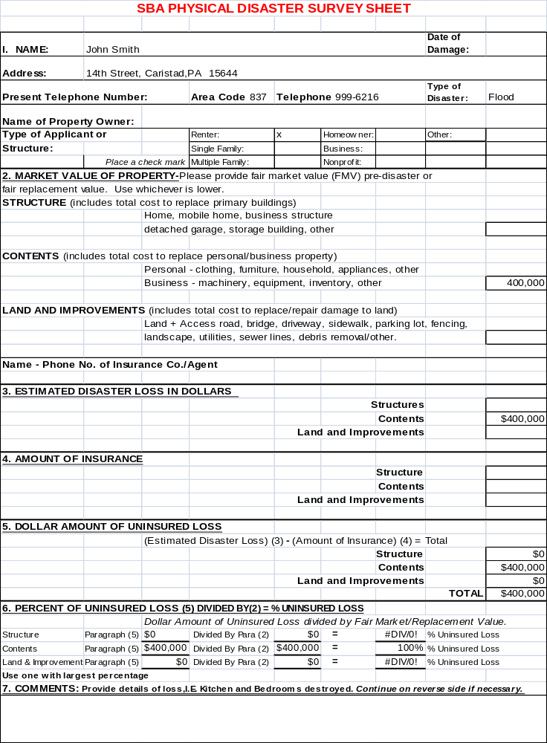
Figure 10

PDL Consolidation

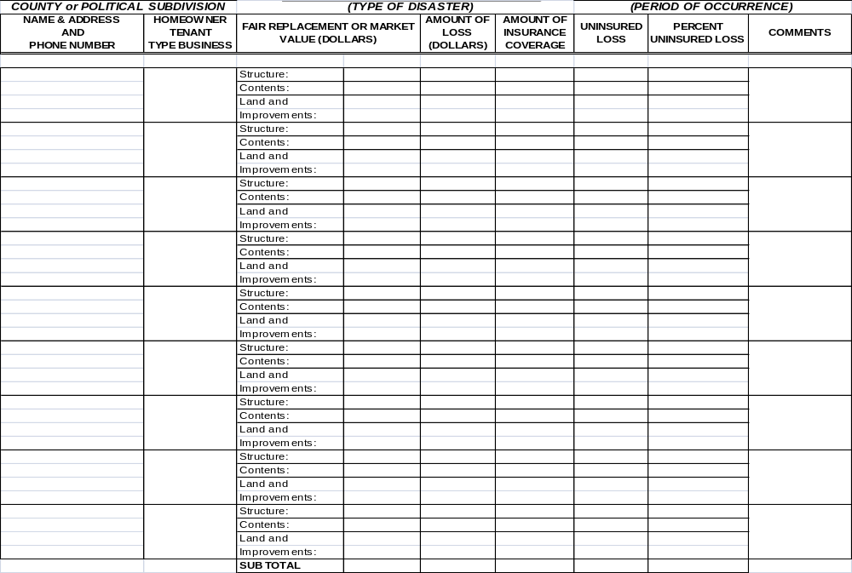
Figure 11

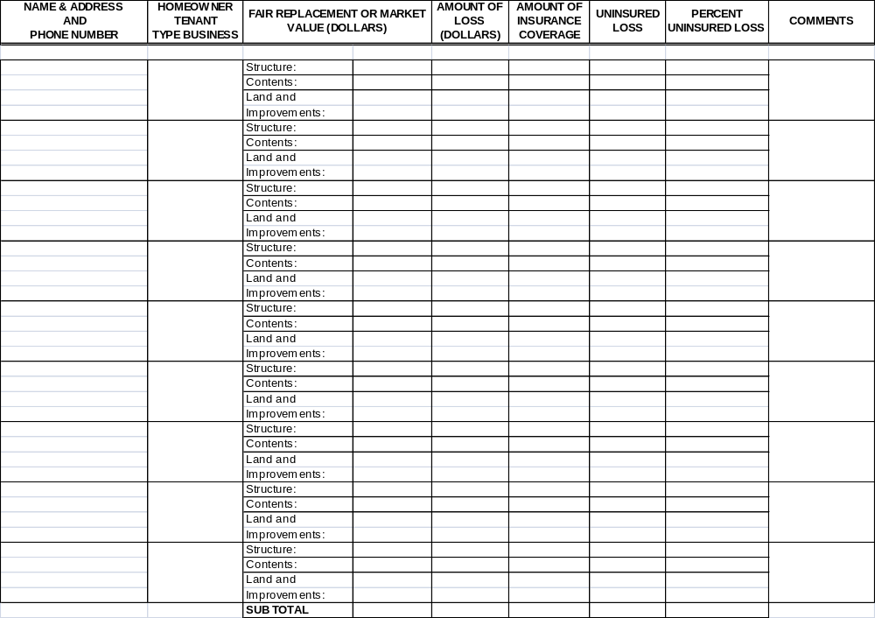
Figure 12
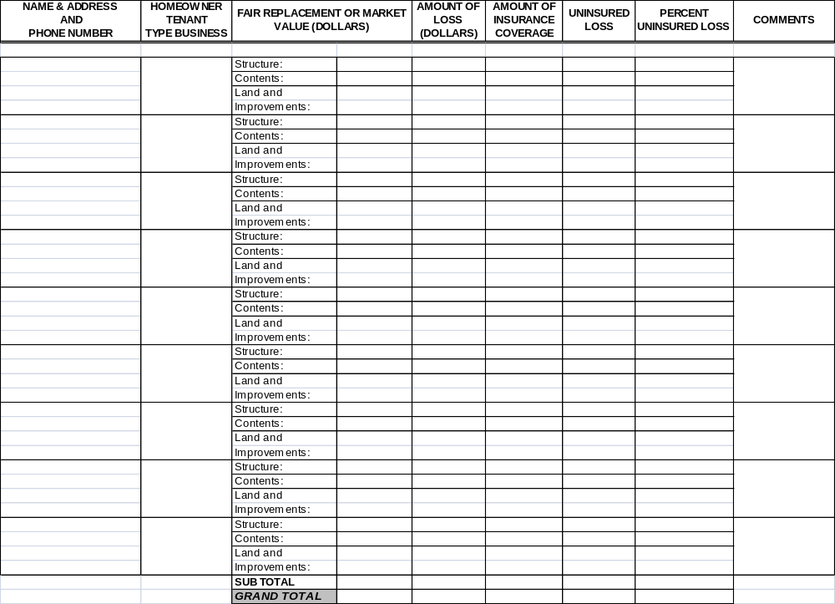
Figure 13

PDL Sample Consolidation

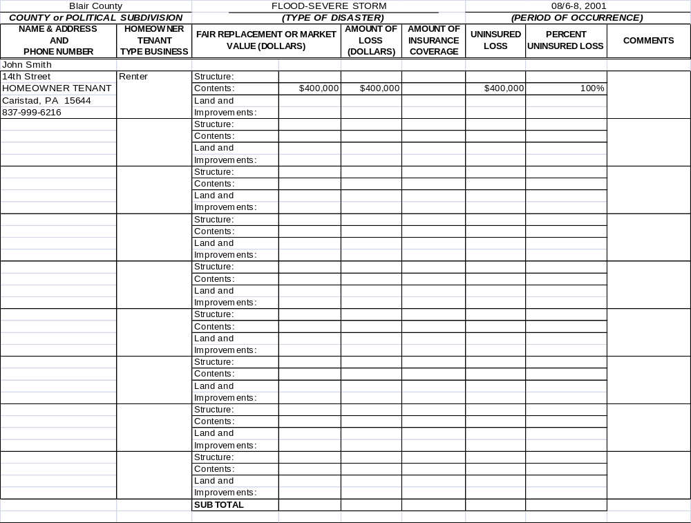
Figure 14
Figure 15
Figure 16

New EIDL Survey

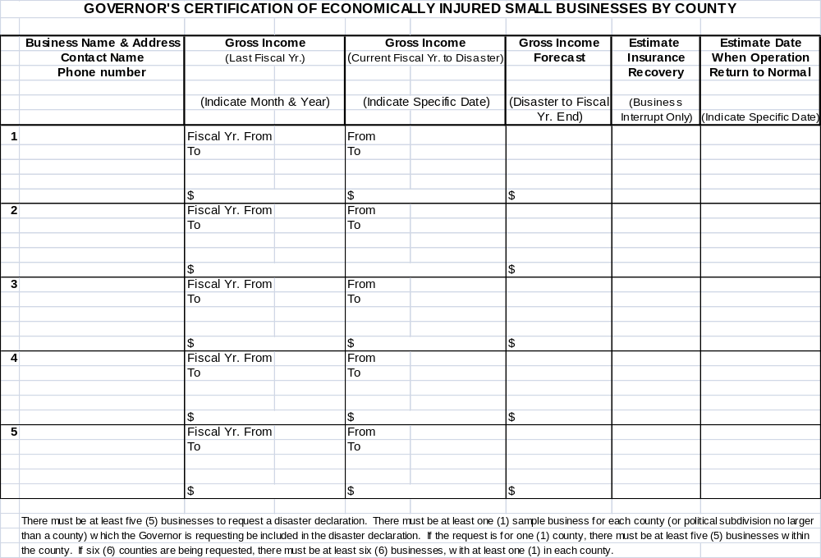
Figure 17

Sample EIDL Survey

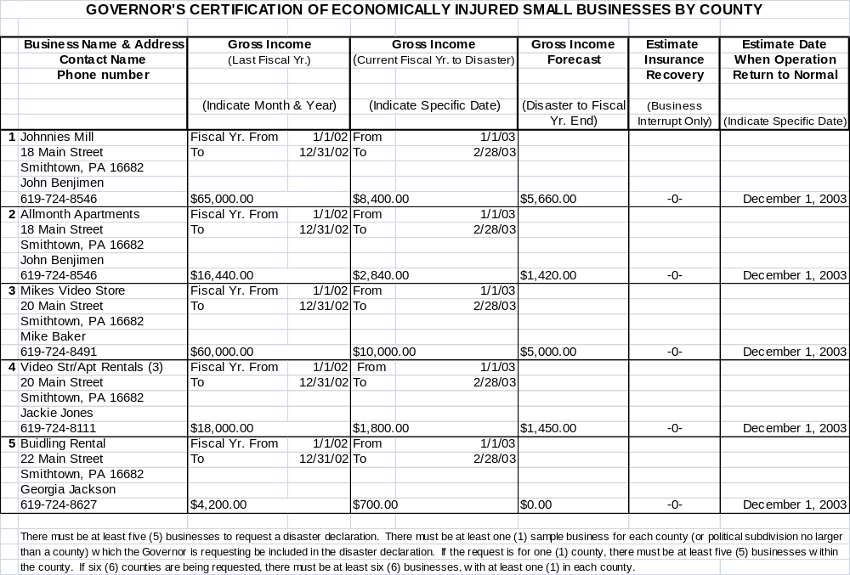
Figure 18

EIDL Questionnaire

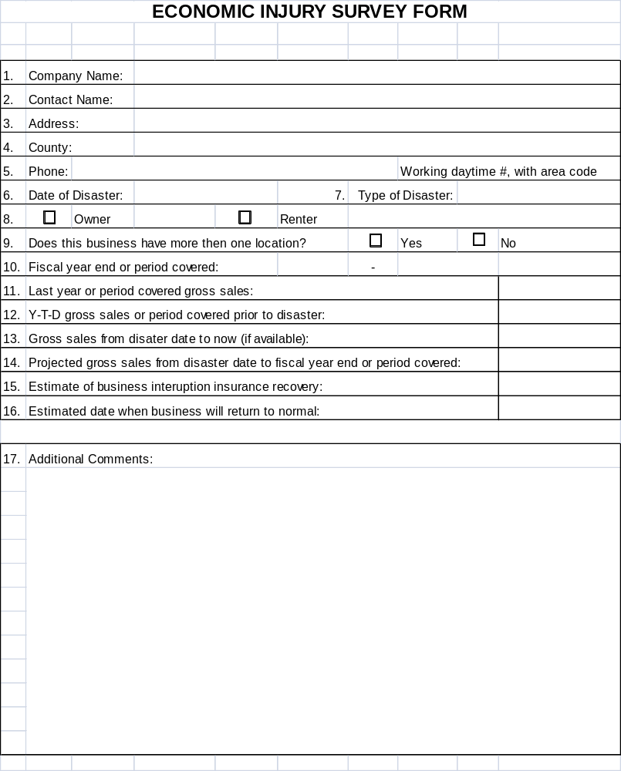
Figure 19

EIDL Sample Questionnaire

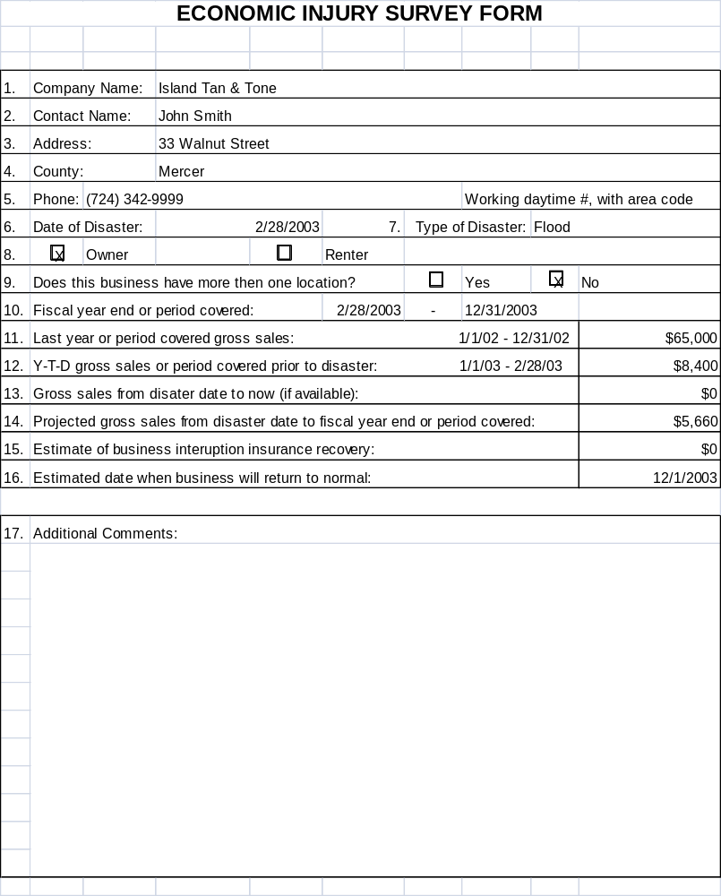
Figure 20

EIDL Survey

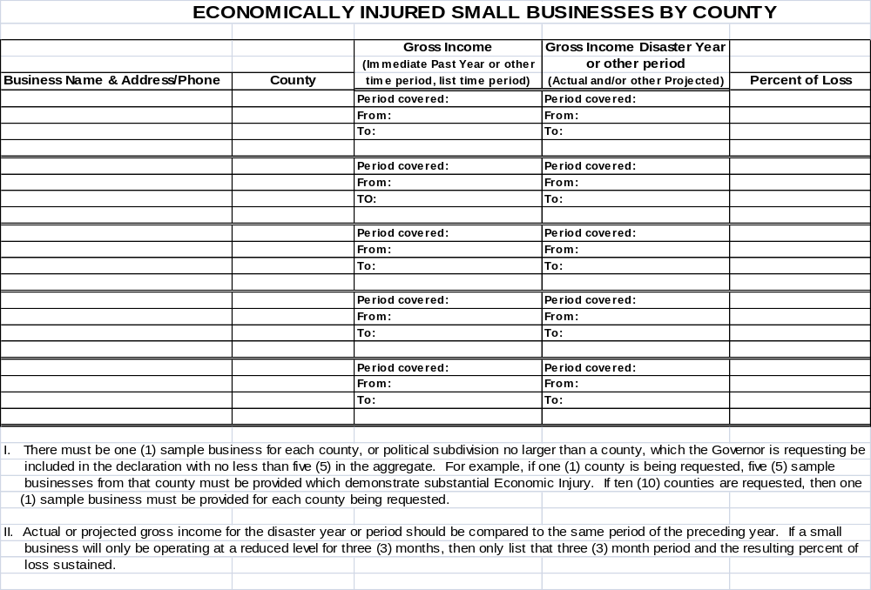
Figure 21

EIDL Sample Survey

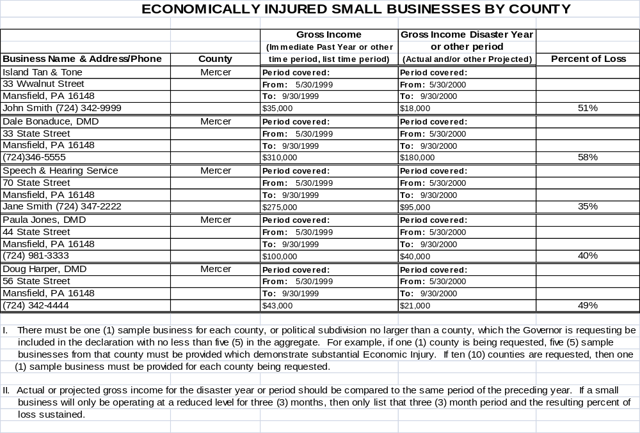
Figure 22

Implementation Procedures

No notification exists.

No task exists.

No resource need exists.

No incident facilities exists.

